CSS (Cascading Style Sheets):

* --> Basic Concepts
* Syntax and Selectors
* Colors
* Text
* Fonts
* Links
* Lists
* Tables
* --> Box Model
* Margin
* Padding
* Border
* Outline
* --> Backgrounds and Borders
* Background Color
* Background Image
* Background Repeat
* Background Position
* Background Attachment
* Border Radius
* Box Shadow
* --> Text and Fonts
* Text Color
* Text Alignment
* Text Decoration
* Text Transform
* Text Indent
* Line Height
* Letter Spacing
* Font Style
* Font Size
* Font Family
* --> Selectors
* Universal Selector
* Type Selector
* Class Selector
* ID Selector
* Attribute Selector
* Pseudo-classes
* Pseudo-elements
* Child Selector
* Adjacent Sibling Selector
* --> Layout
* Display
* Positioning (Static, Relative, Absolute, Fixed, Sticky)
* Z-index
* Float
* Clear
* Flexbox
* Grid
* --> Responsive Design
* Media Queries
* Viewport
* Responsive Units (vw, vh, %, etc.)
* --> Animations and Transitions
* Transitions
* Animations
* Keyframes
* --> CSS Functions
* calc()
* var()
* url()
* rgba(), hsla()
* --> Miscellaneous
* CSS Variables (Custom Properties)
* @font-face
* @import
* Shorthand Properties
* --> Advanced Topics
* CSS Preprocessors (LESS, SASS)
* CSS Frameworks (Bootstrap, Tailwind)
* CSS-in-JS
* Custom Properties (CSS Variables)
* This list covers a wide range of topics within CSS, from the basics to advanced concepts. If you want details on any specific topic, let me know! 😊

**1. Syntax and Selectors**

Theory: CSS (Cascading Style Sheets) is used to style and layout web pages. It allows you to select HTML elements and apply styles to them.

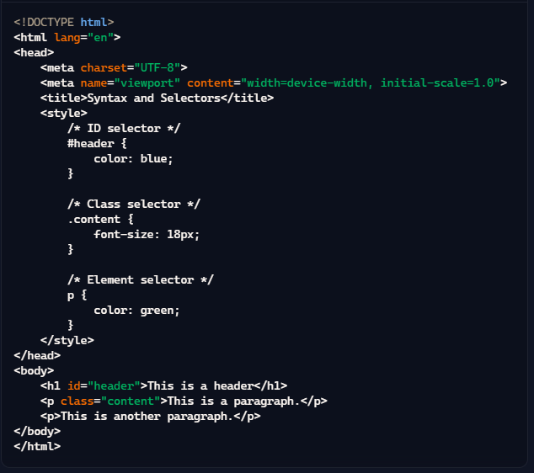

### 2. Colors

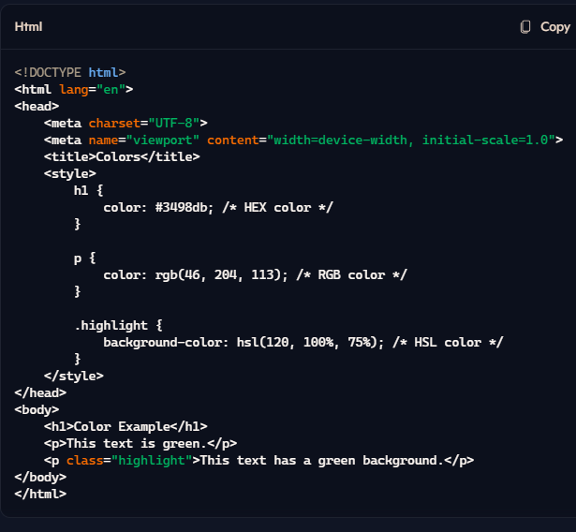**Theory:** CSS allows you to set colors for various elements using keywords, HEX, RGB, or HSL values.

### 3. Text

**Theory:** CSS provides properties to style text, including color, alignment, decoration, and transformation.  
Text properties in CSS allow you to control the appearance of text, including its color, alignment, decoration (like underline), transformation (like uppercase), and spacing between letters and lines.

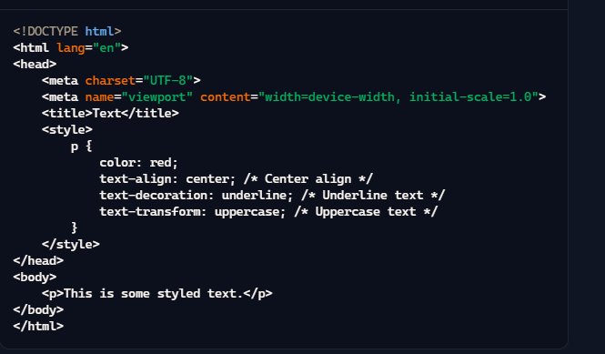

### 4. Fonts

**Theory:** You can specify the font family, size, weight, and style using CSS.   
Font properties allow you to specify the font family (typeface), size, weight (thickness), and style (like italic) of text. This helps in enhancing readability and aesthetic appeal of the text content on web pages.

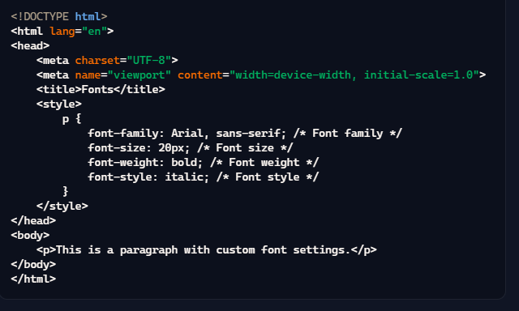

### 5. Links

**Theory:** CSS allows you to style links and their various states (hover, visited, active).  
Link styling in CSS enables you to define how hyperlinks should look in different states, such as normal, visited, hover, and active states. This improves navigation and user experience on a webpage.

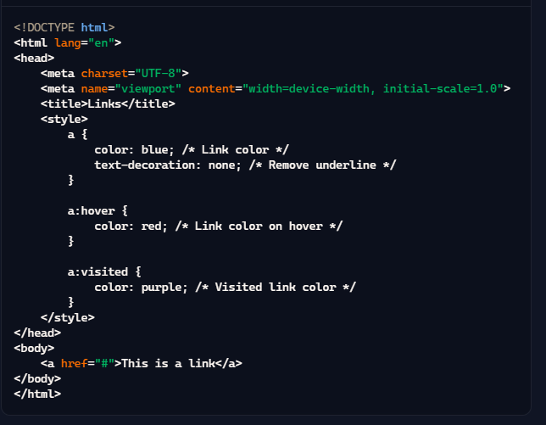

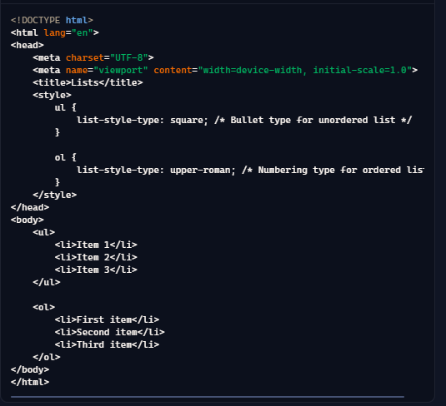6. **Lists**  
**Theory:** CSS can be used to style lists, including bullet points, numbering, and custom markers.

### 7. Tables

**Theory:** CSS can style tables, including borders, spacing, and alignment. Tables are used to display tabular data in a structured format. CSS allows you to style tables by setting properties for borders, spacing, alignment, and background colors to make the table data more readable and visually appealing.

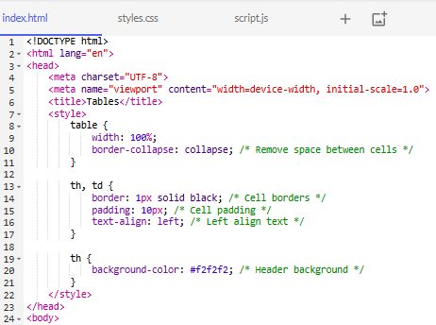

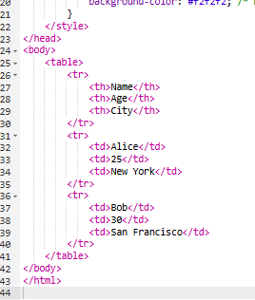

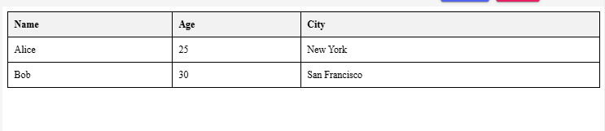

* --> Box Model
* Margin
* Padding
* Border
* Outline

### Box Model

**Theory:** The CSS box model is a fundamental concept that describes how elements are structured and displayed on a web page. Every element is essentially a rectangular box, and the box model consists of the following components:

1. **Content**: The actual content of the element, such as text or images.
2. **Padding**: Space between the content and the border.
3. **Border**: A border that surrounds the padding and content.
4. **Margin**: Space outside the border, separating the element from other elements.
5. **Outline**: A line drawn outside the border to make the element stand out, but not affecting the layout.

### Example with Explanation:

### Explanation:

1. **Content**: The actual text inside the div element.
2. **Padding**: padding: 20px; creates 20px space inside the border, around the content.
3. **Border**: border: 5px solid black; adds a solid black border with a thickness of 5px around the padding.
4. **Margin**: margin: 15px; adds 15px space outside the border, separating this element from others.
5. **Outline**: outline: 2px dashed red; adds a dashed red line outside the border, but it doesn't affect the layout or the position of the element.

### Component Breakdown:

#### 1. Margin

**Theory:** The margin is the outermost layer, creating space between the element's border and adjacent elements. It can be set for all sides (top, right, bottom, left) individually or together.

**Example:**

**<div class="margin-example">**

**This element has a margin.**

**</div>**

**<style>**

**.margin-example {**

**margin: 20px; /* 20px margin on all sides */**

**}**

**</style>**

**Explanation:** The margin property sets a uniform margin of 20px on all sides of the element.

#### 2. Padding

**Theory:** Padding is the space between the content and the border of an element. It ensures the content doesn't touch the border directly. It can also be set for all sides individually or together.

**Example:**

<div class="padding-example">

This element has padding.

</div>

<style>

.padding-example {

padding: 10px; /* 10px padding on all sides */

}

</style>

**Explanation:** The padding property sets a uniform padding of 10px on all sides of the element.

#### 3. Border

**Theory:** The border surrounds the padding and content. It can have various styles (solid, dashed, dotted), widths, and colors.

**Example:**

<div class="border-example">

This element has a border.

</div>

<style>

.border-example {

border: 2px solid blue; /* 2px solid blue border */

}

</style>

**Explanation:** The border property sets a 2px solid blue border around the element.

#### 4. Outline

**Theory:** The outline is similar to a border but does not affect the element's size or layout. It is drawn outside the border and can help highlight elements.

**Example:**

**<div class="outline-example">**

**This element has an outline.**

**</div>**

**<style>**

**.outline-example {**

**outline: 3px dotted red; /* 3px dotted red outline */**

**}**

**</style>**

**Explanation:** The outline property sets a 3px dotted red outline around the element, which doesn't affect the element's layout or size.

* --> Backgrounds and Borders
* Background Color
* Background Image
* Background Repeat
* Background Position
* Background Attachment
* Border Radius
* Box Shadow

### Backgrounds and Borders in CSS

CSS allows you to style the backgrounds and borders of HTML elements in various ways. Let's go through each of the listed properties with a brief theory and an example.

### 1. Background Color

**Theory:** The background-color property sets the background color of an element.

**Example:**

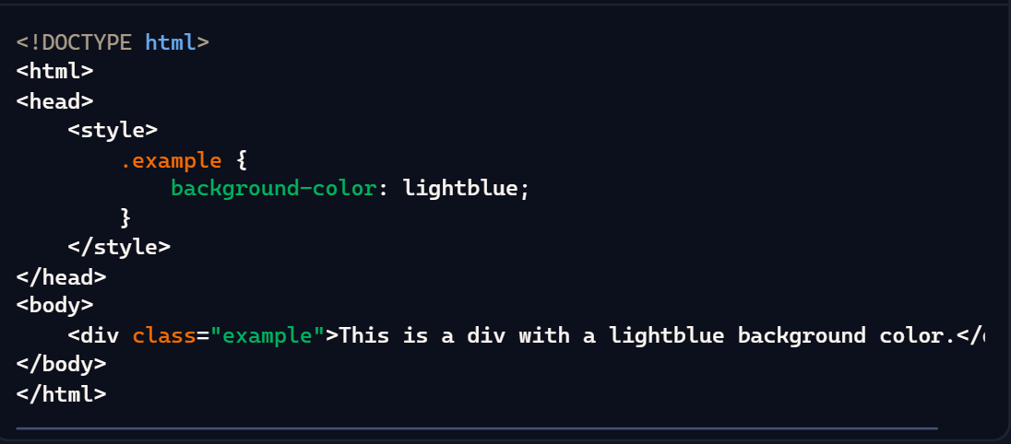

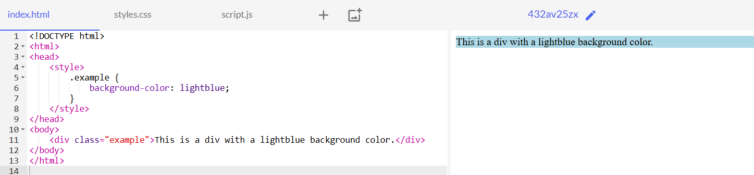

### 2. Background Image

**Theory:** The background-image property sets an image as the background of an element.

**Example:**

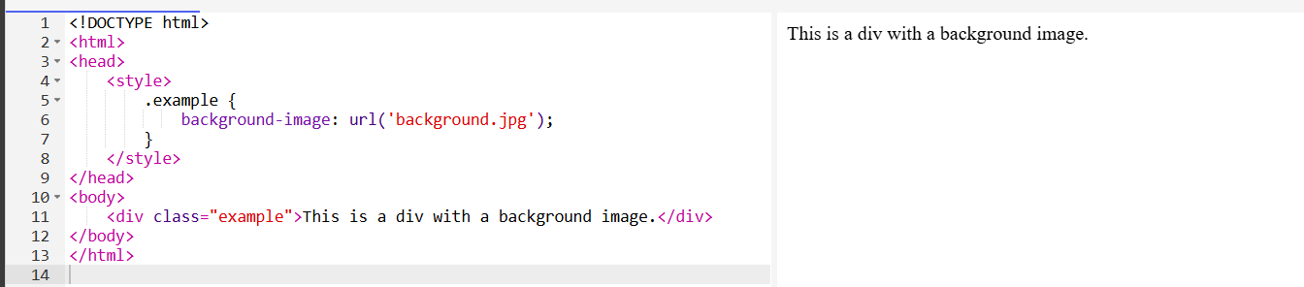

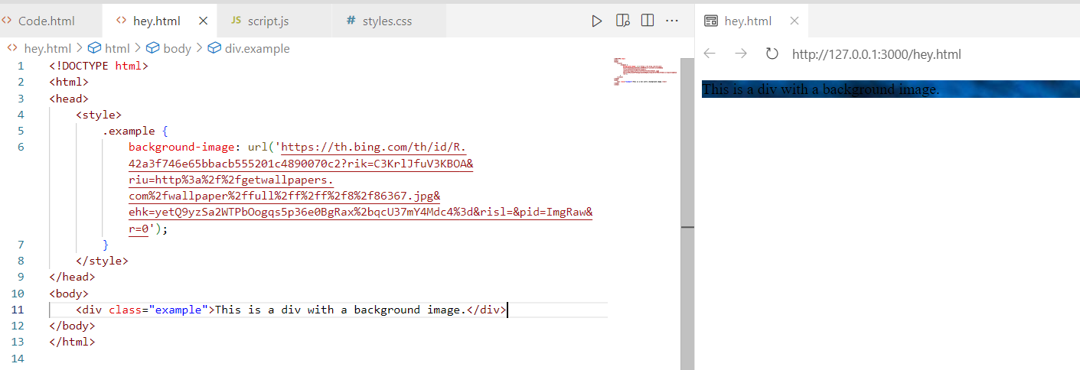

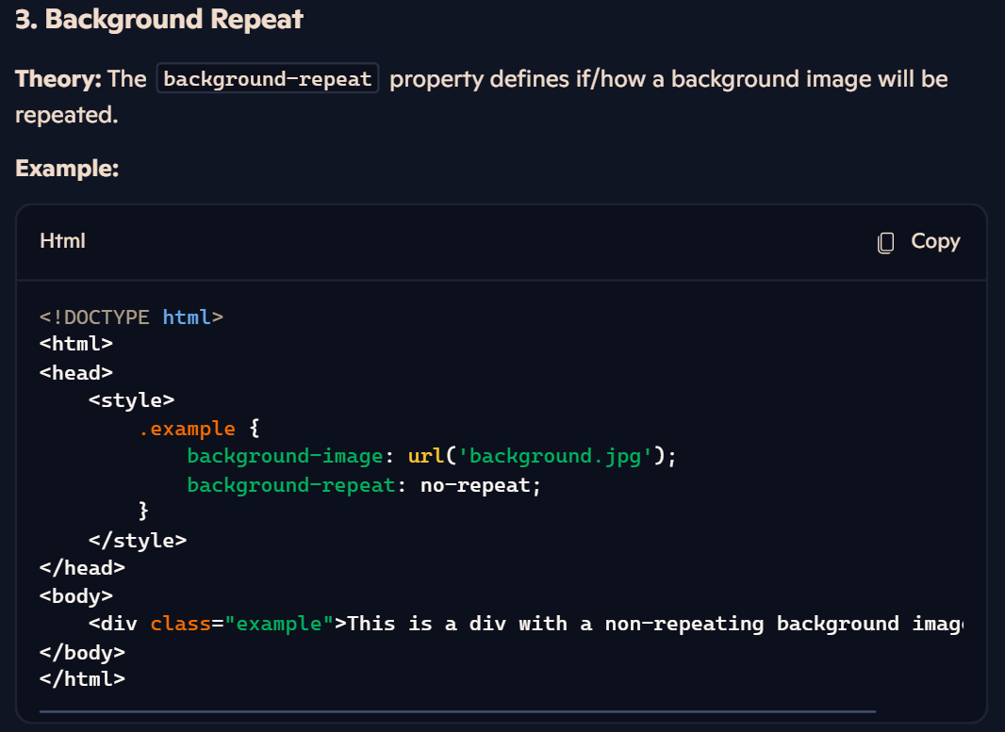

### 4. Background Position

**Theory:** The background-position property sets the initial position of the background image.

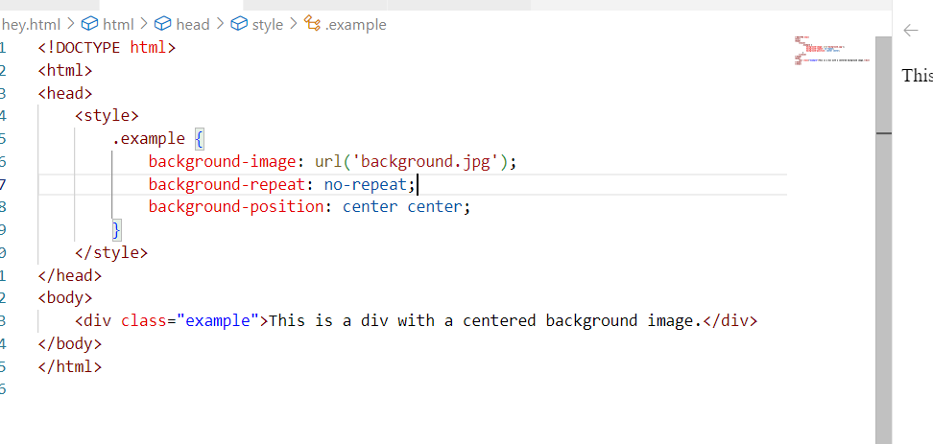

**5. Background Attachment**

**Theory:** The background-attachment property sets whether a background image is fixed or scrolls with the rest of the page.

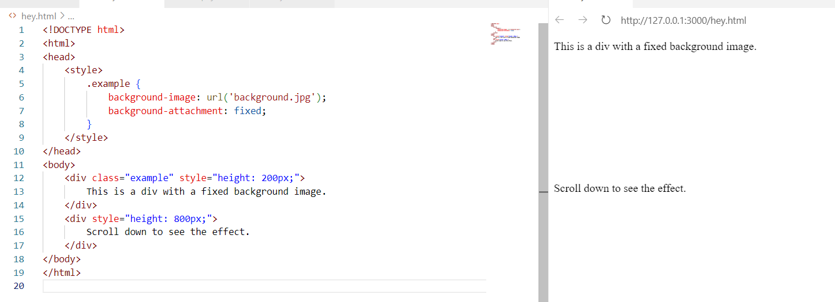  
Scrolling Effect :

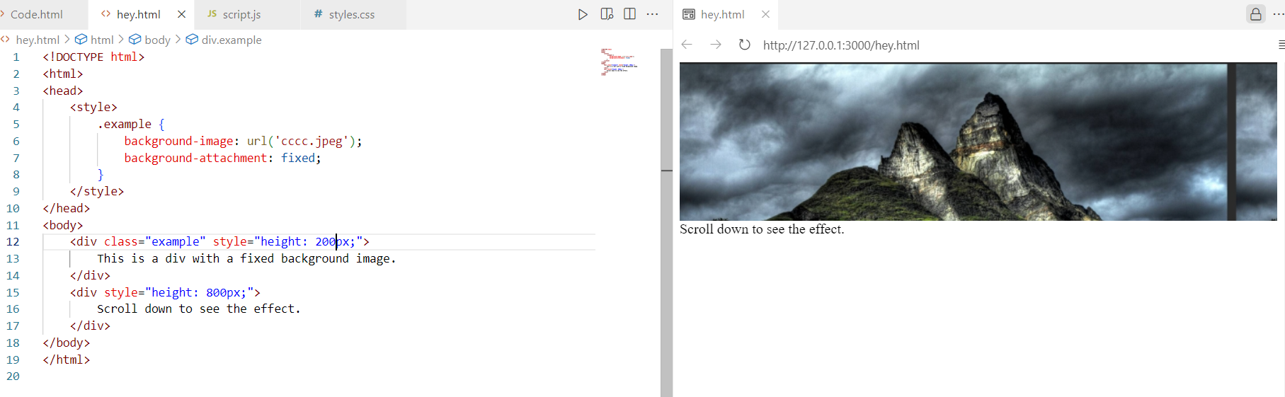

### 6. Border Radius

**Theory:** The border-radius property defines the radius of the element's corners.

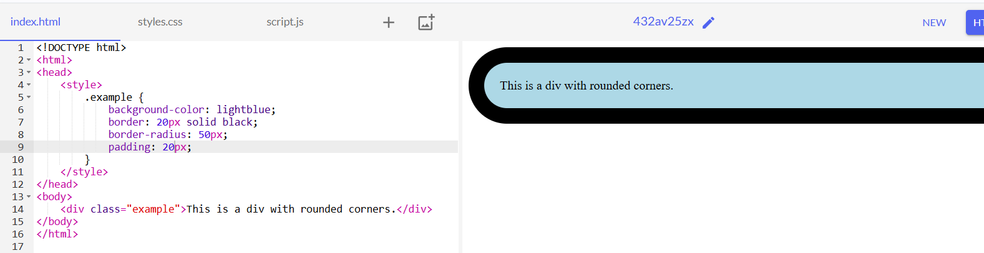

**Box Shadow Theory**

**Theory:** The box-shadow property adds shadow effects around an element's frame. You can specify the shadow's color, size, blur, and spread.

**Syntax:**

box-shadow: h-offset v-offset blur spread color;

* **h-offset (horizontal offset):** Moves the shadow horizontally. Positive values move the shadow to the right, and negative values move it to the left.
* **v-offset (vertical offset):** Moves the shadow vertically. Positive values move the shadow down, and negative values move it up.
* **blur:** Defines the blur radius of the shadow. Higher values create more blur.
* **spread:** Defines the spread radius. Positive values expand the shadow, and negative values shrink it.
* **color:** Specifies the color of the shadow.

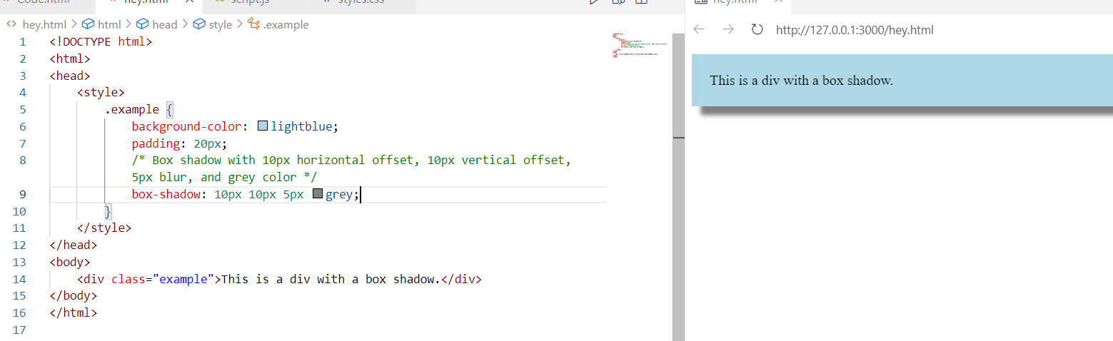

* --> Text and Fonts
* Text Color
* Text Alignment
* Text Decoration
* Text Transform
* Text Indent
* Line Height
* Letter Spacing
* Font Style
* Font Size
* Font Family

**CSS: Text and Fonts**

Understanding how to style text and fonts in CSS is essential for creating visually appealing web pages. Below are key properties with brief explanations and examples for each.

**1. Text Color**

**Theory:** The color property sets the color of the text content of an element.

**Example:**

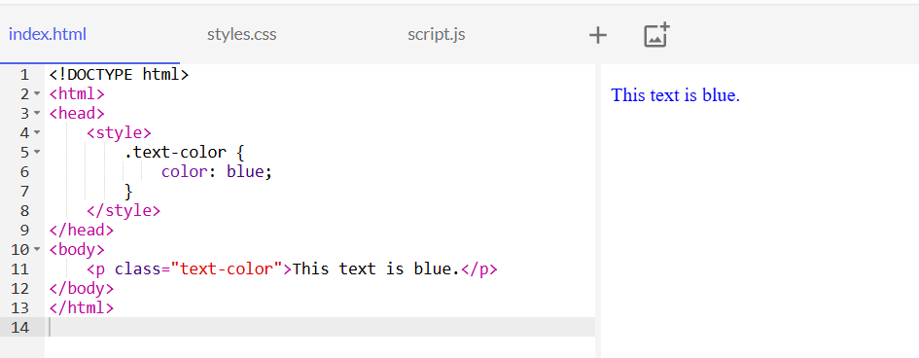

**2. Text Alignment**

**Theory:** The text-align property sets the horizontal alignment of text within an element.

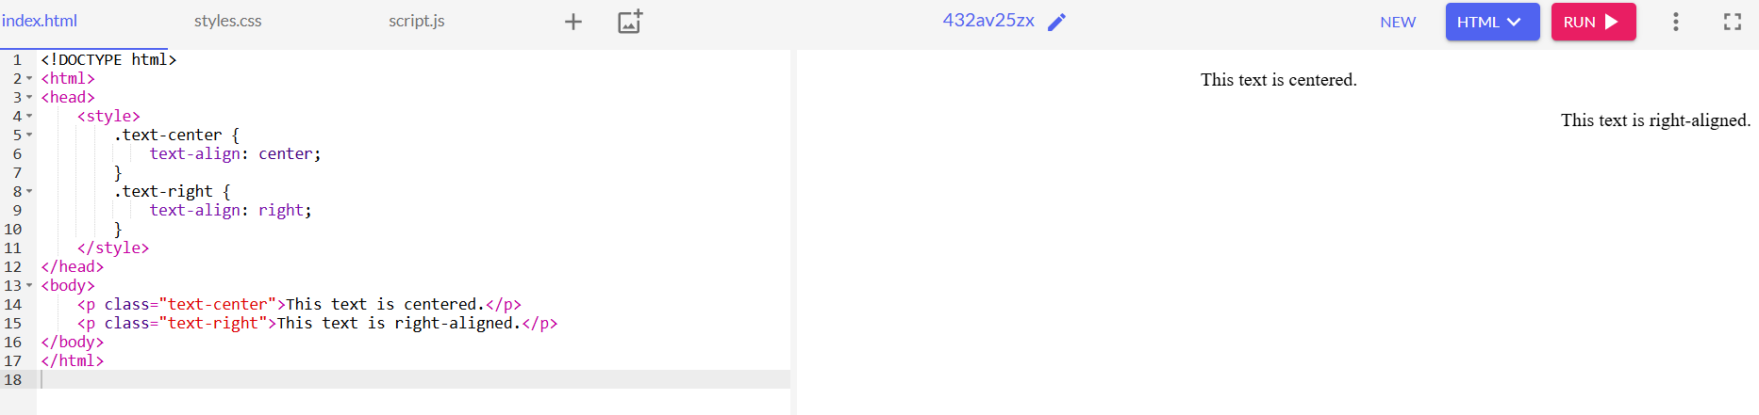

### 3. Text Decoration

**Properties:**

* text-decoration: Adds decorations to the text (e.g., underline, overline, line-through, none).

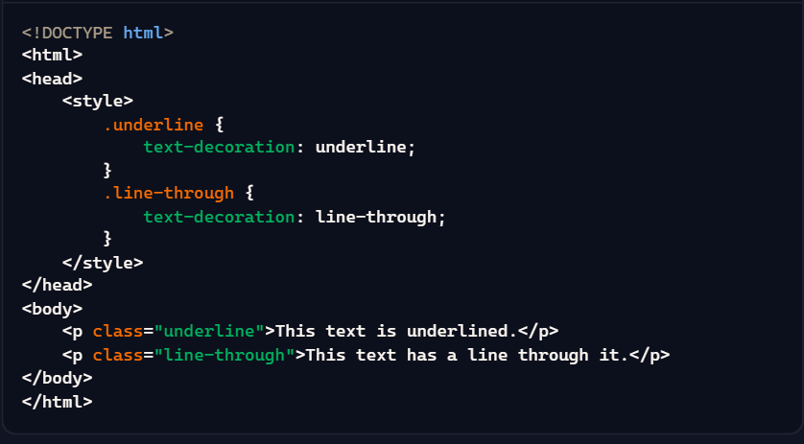

### 4. Text Transform

**Properties:**

* text-transform: Controls the capitalization of text. Possible values are **capitalize, uppercase, lowercase, none.**

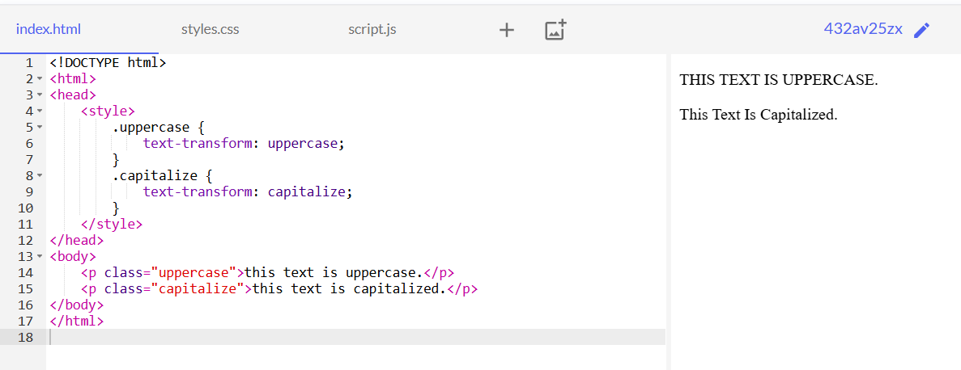

### 5. Text Indent

**Properties:**

* text-indent: Specifies the indentation of the first line of text in a block.

**Example:**

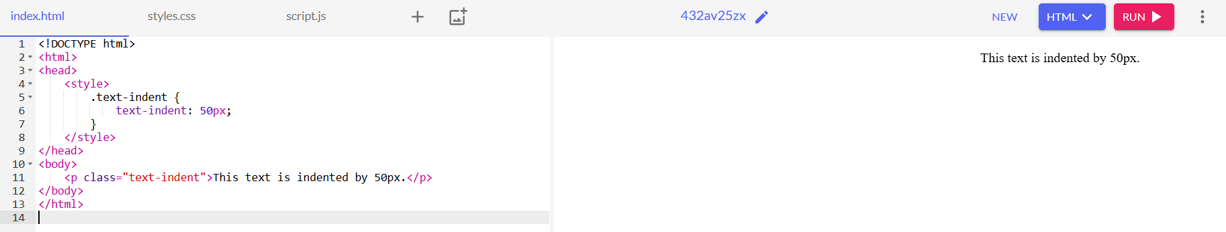

### 6. Line Height

**Properties:**

* line-height: Sets the amount of space between lines of text.

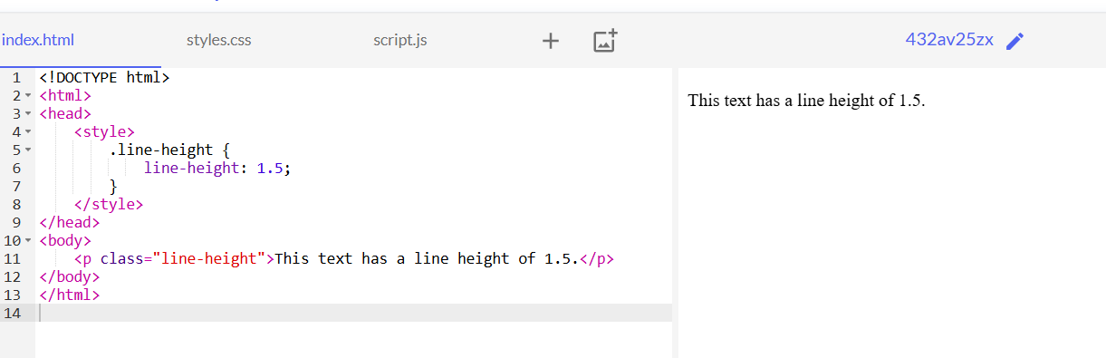

### 7. Letter Spacing

**Properties:**

* letter-spacing: Sets the space between characters in text.

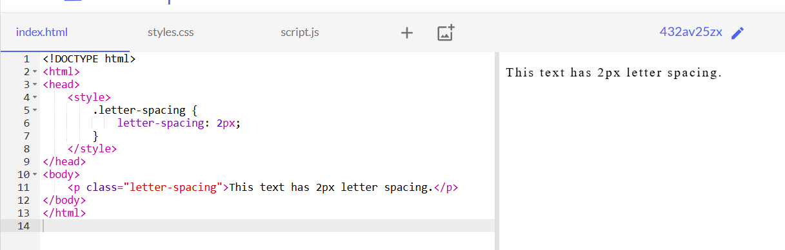

### 8. Font Style

**Properties:**

* **font-style: Sets the style of the font, such as normal, italic, or oblique.**

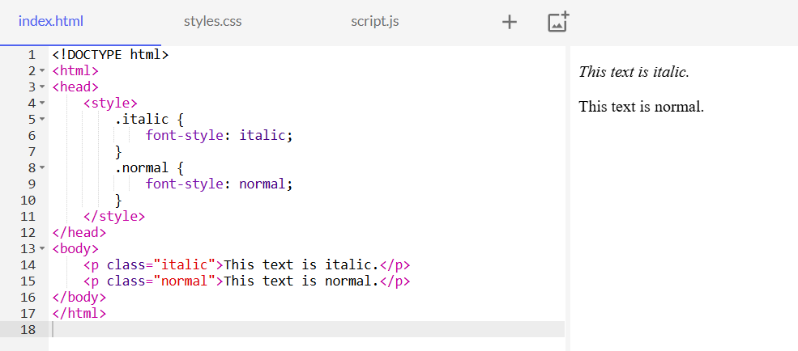

### 9. Font Size

**Properties:**

* font-size: Sets the size of the text.

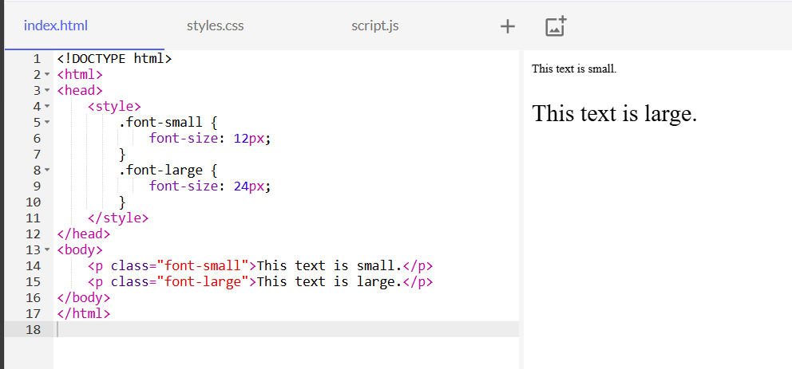

### 10. Font Family

**Properties:**

* font-family: Specifies the typeface to be used for text.

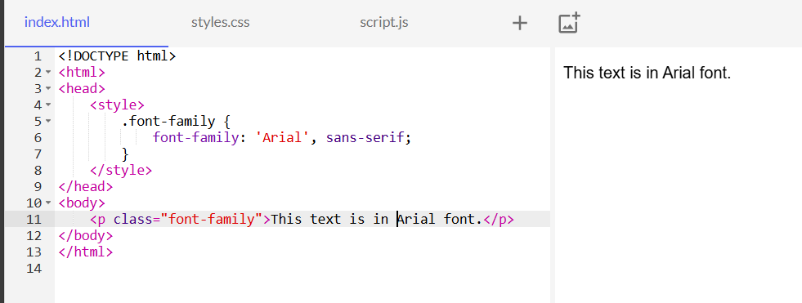

* --> Selectors
* Universal Selector
* Type Selector
* Class Selector
* ID Selector
* Attribute Selector
* Pseudo-classes
* Pseudo-elements
* Child Selector
* Adjacent Sibling Selector

**1. Universal Selector**

**Theory:** The universal selector (*) selects all elements on the page.

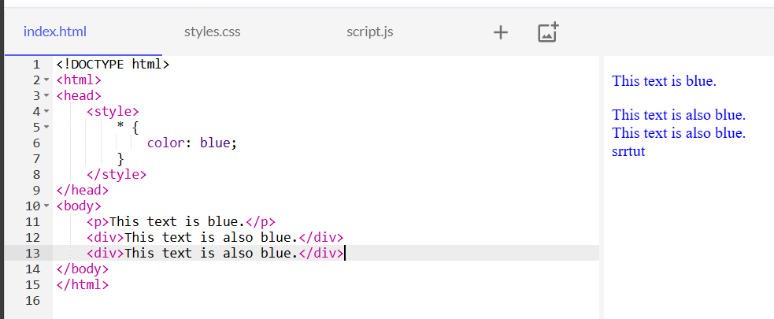

**2. Type Selector**

**Theory:** The type selector selects all elements of a given type.

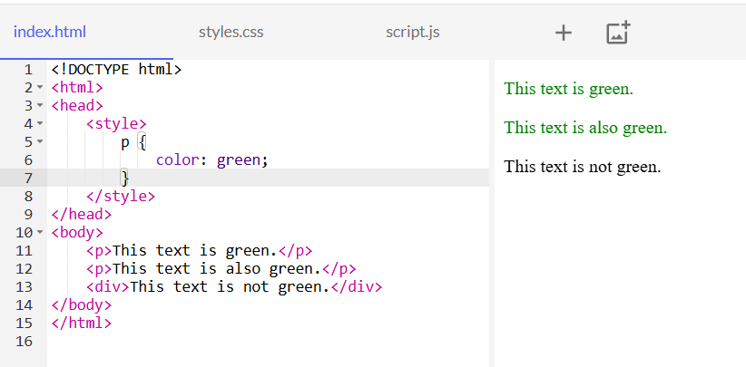

**3. Class Selector**

**Theory:** The class selector selects all elements with a specific class attribute. It uses a period (.) followed by the class name.

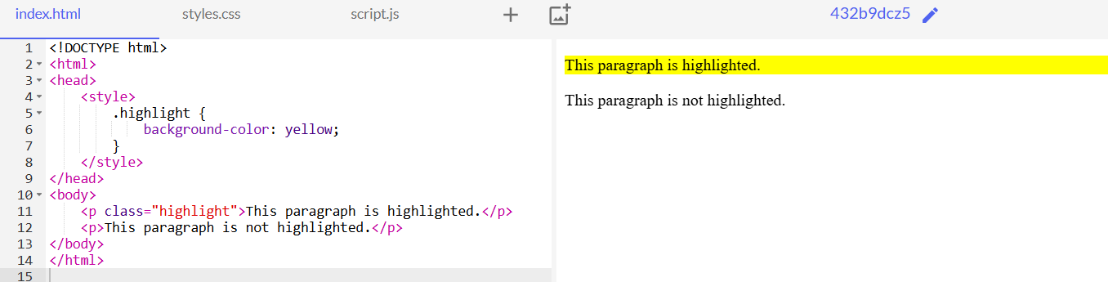

**4. ID Selector**

**Theory:** The ID selector selects a single element with a specific ID attribute. It uses a hash (#) followed by the ID name.

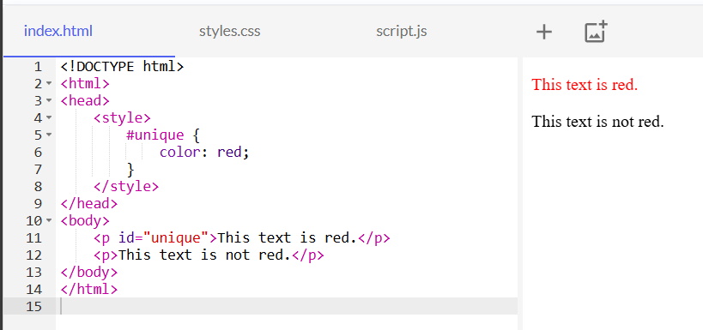

**5. Attribute Selector**

**Theory:** The attribute selector selects elements with a specific attribute or attribute value.

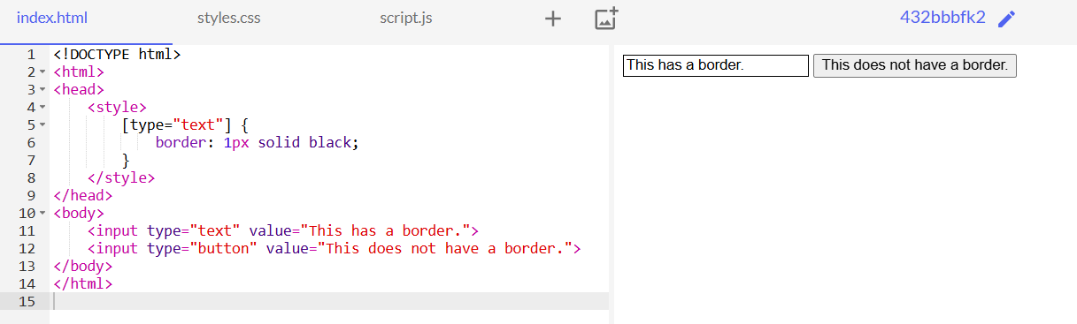

**6. Pseudo-classes**

**Theory:** Pseudo-classes select elements based on their state or position within the document.

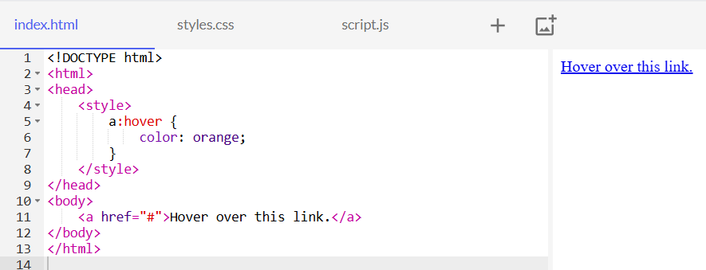

**7. Pseudo-elements**

**Theory:** Pseudo-elements select and style a part of an element.

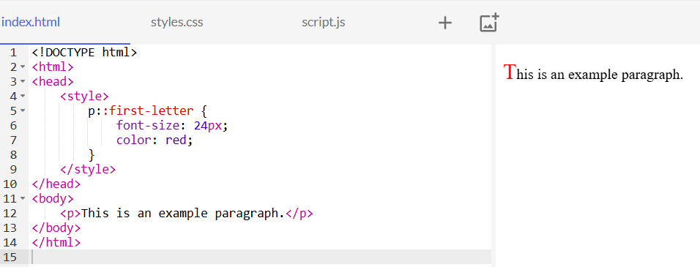

**8. Child Selector**

**Theory:** The child selector (>) selects elements that are direct children of a specified element.

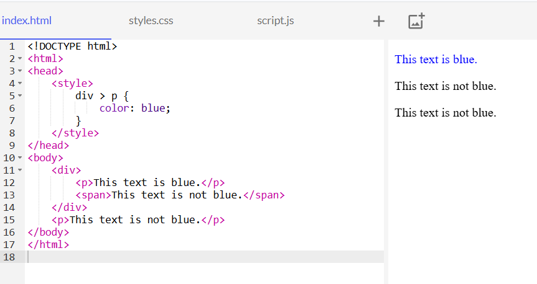

**9. Adjacent Sibling Selector**

**Theory:** The adjacent sibling selector (+) selects an element that is immediately preceded by a specified element.

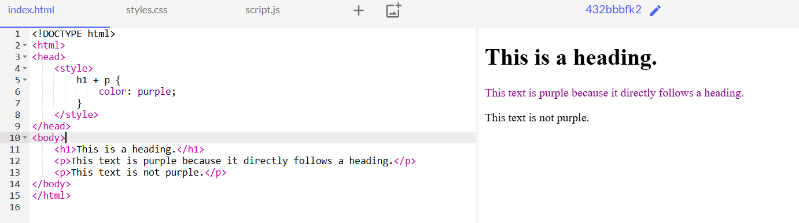

* --> Layout
* Display
* Positioning (Static, Relative, Absolute, Fixed, Sticky)
* Z-index
* Float
* Clear
* Flexbox
* Grid

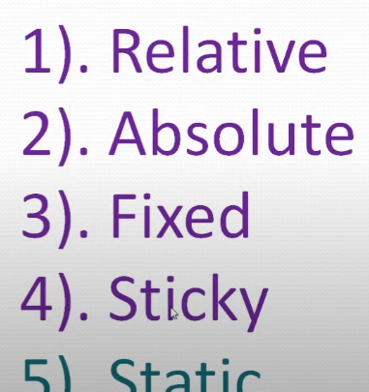

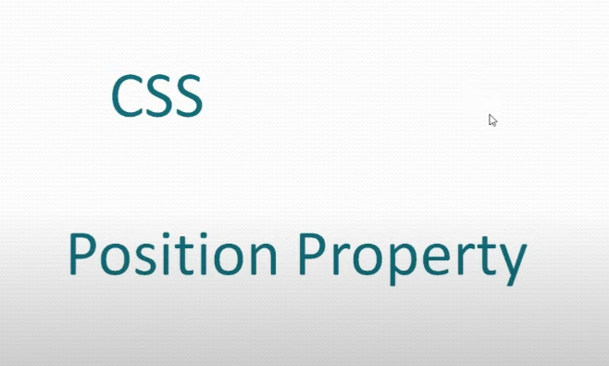

1. **RELATIVE**

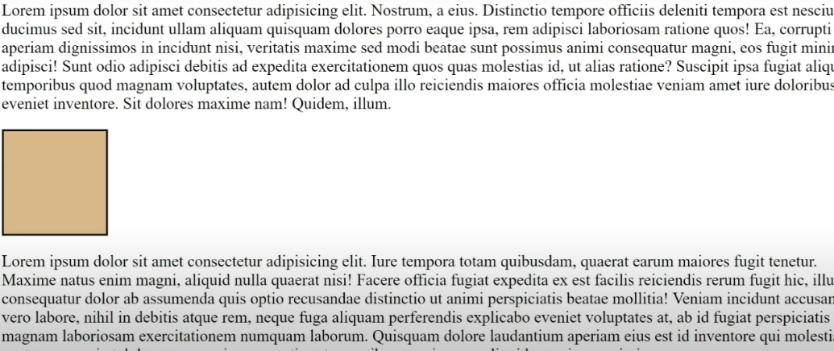

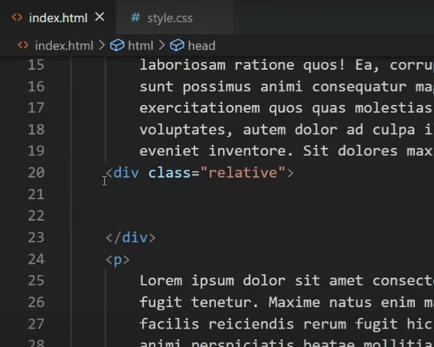

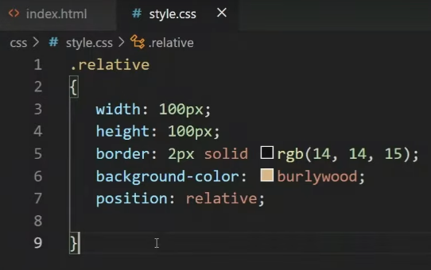

NO : Change for HTML PAGE We Need top ,bottom, left, right

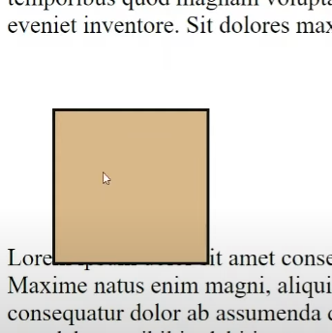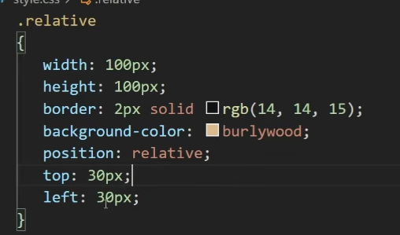

Change for normal position :🡪

1. **ABSOLUTE:**

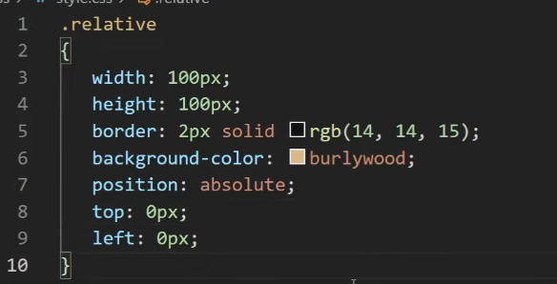

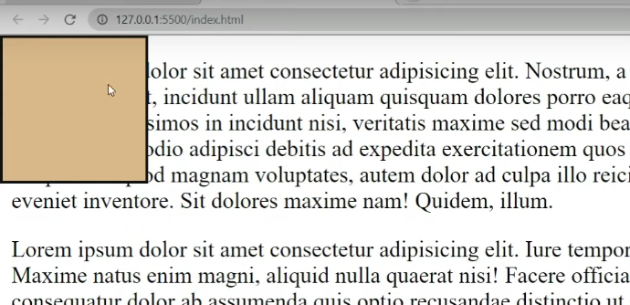

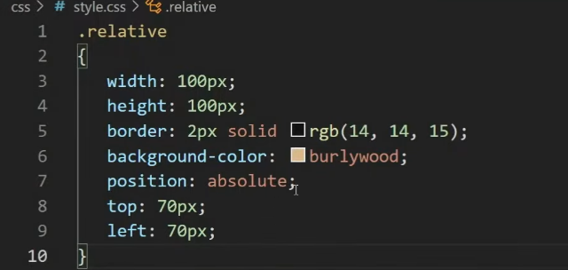

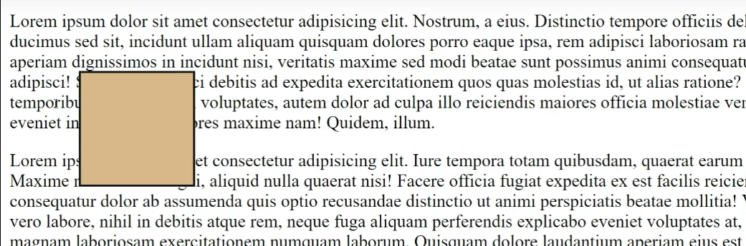

1. 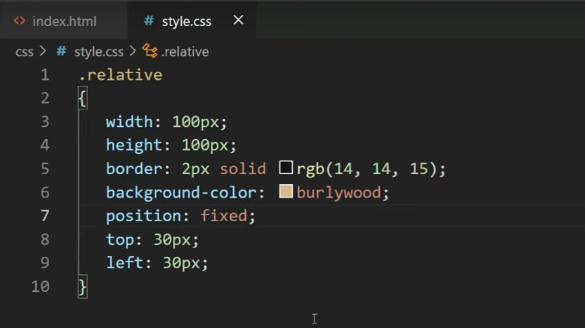FIXIT

**Container (Not MOVE) for scrolling down and up**

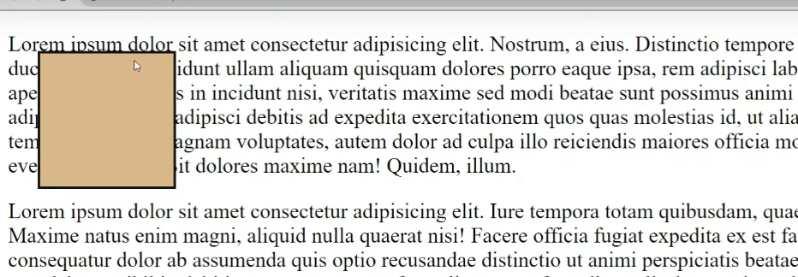

**4. Sticky**

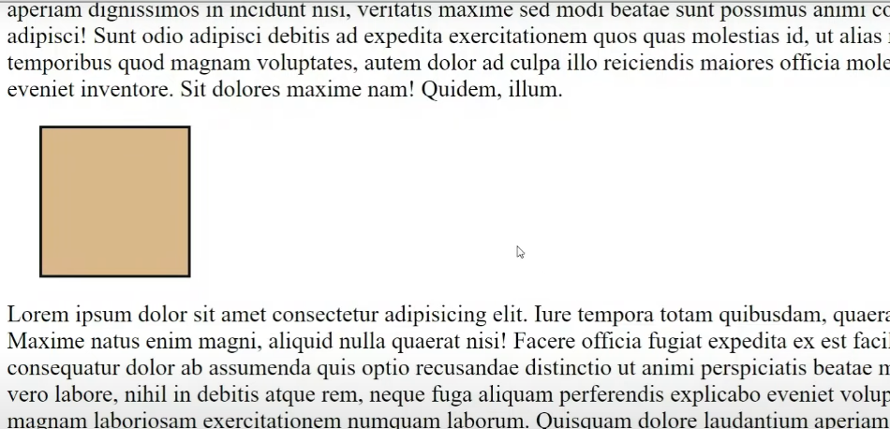

**Orginal is**

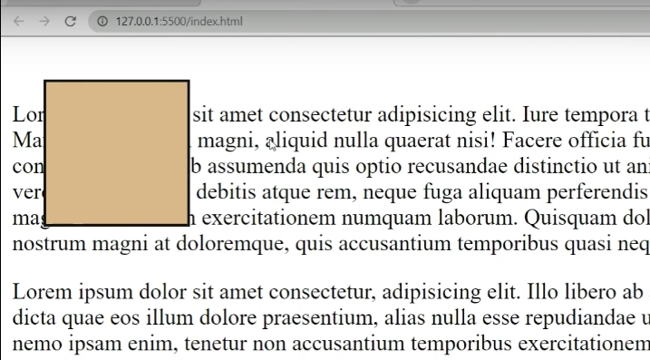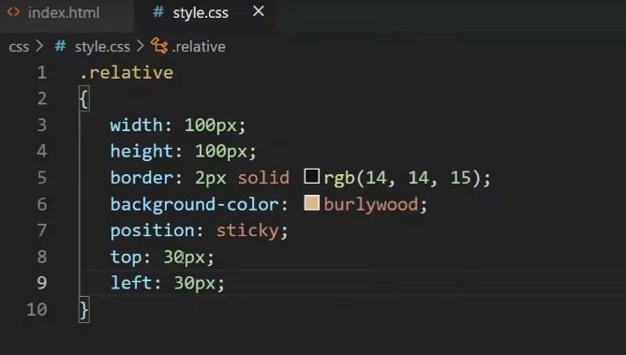 **page scrolling but container fix top and left.(automatically space)**

* Display

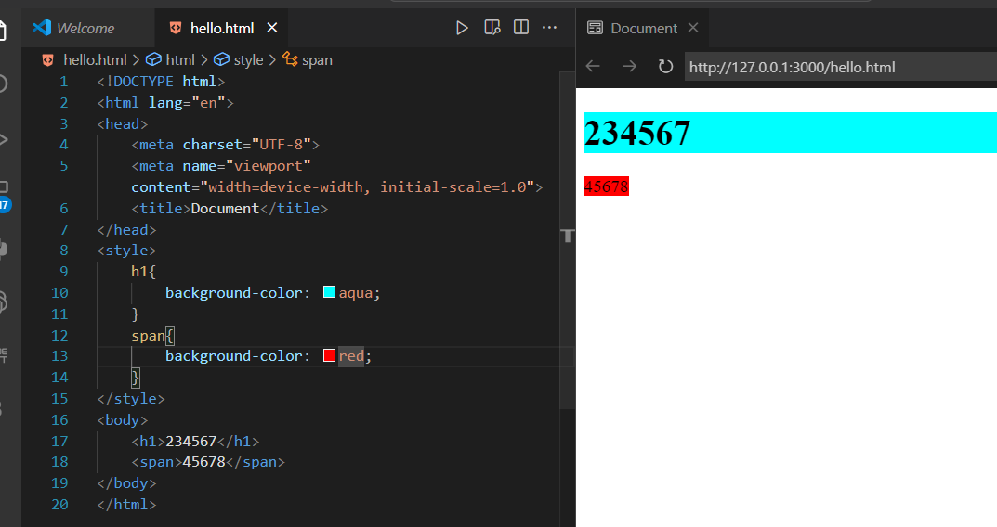

**Use display inline in h1**

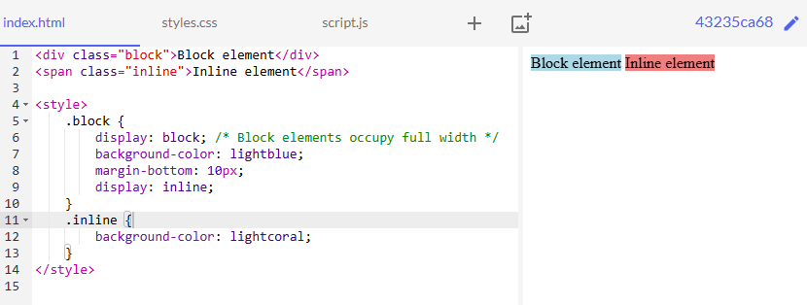

**Use span tag full fill color (like div)**

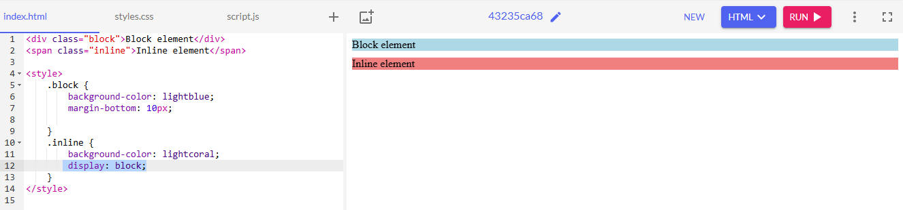

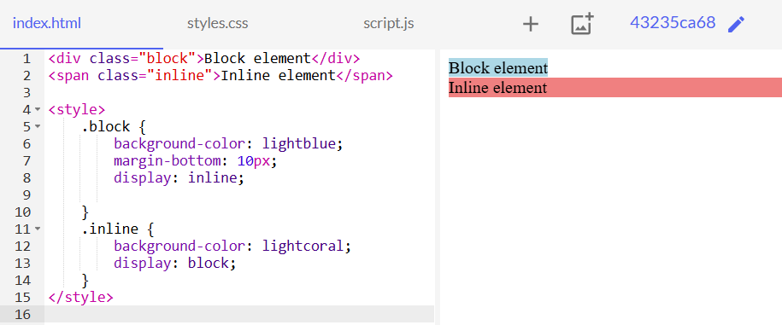

DISPLAY NONE ->

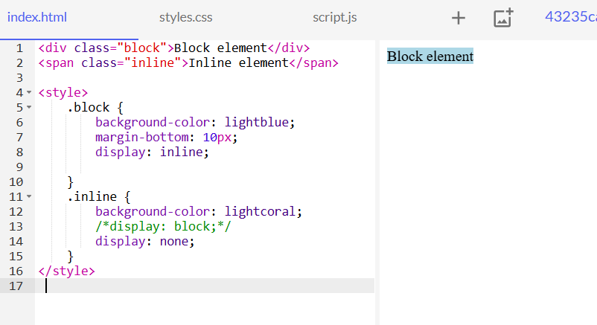

🡪

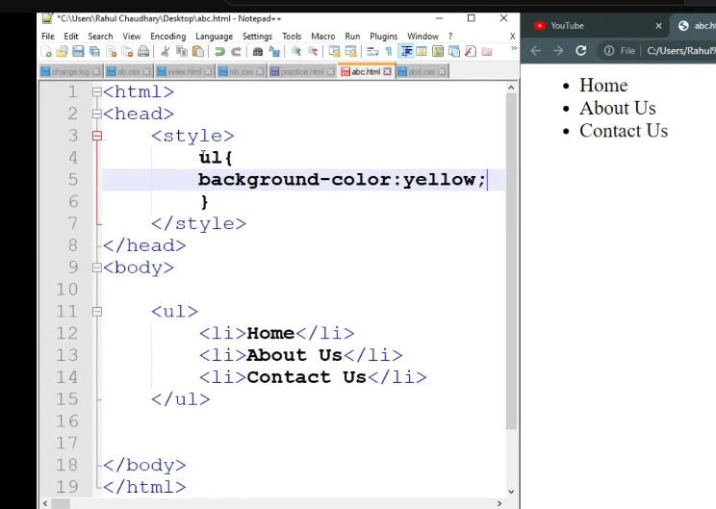

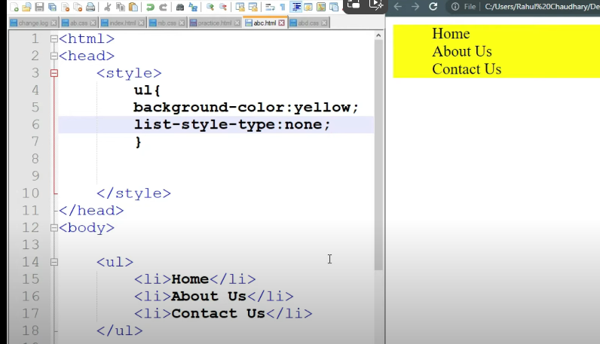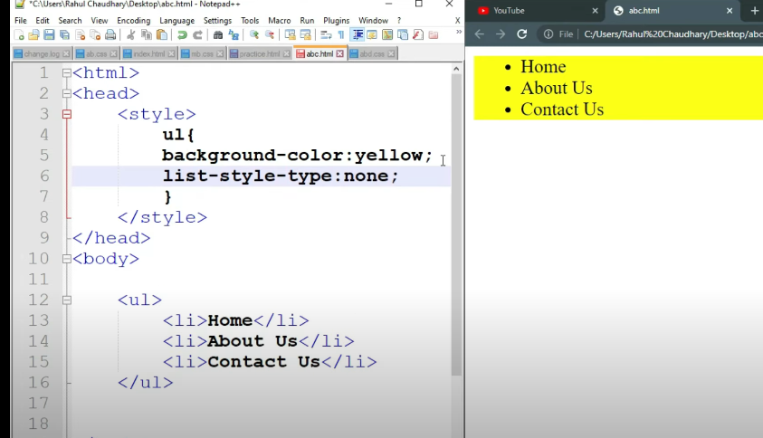

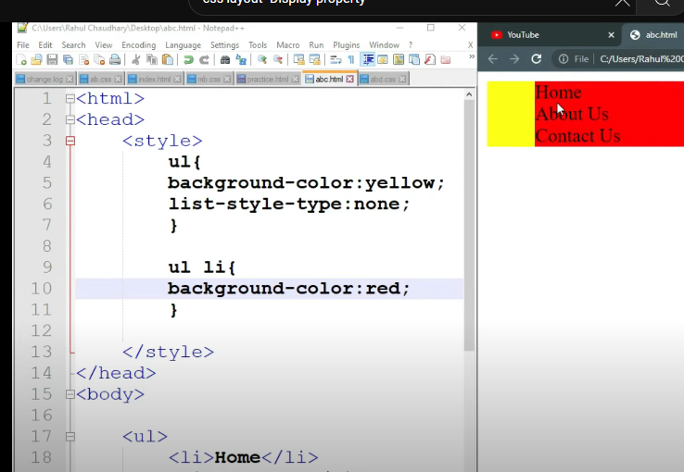

Ul->li Color change

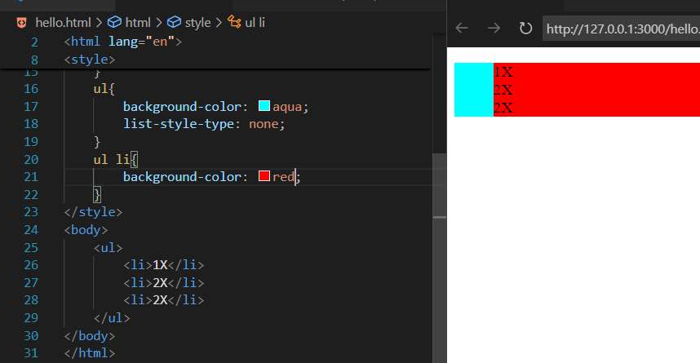

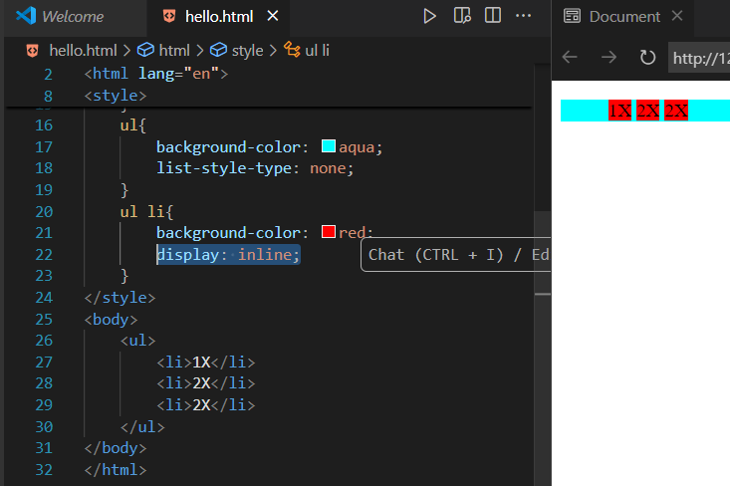

Height & Line height ->

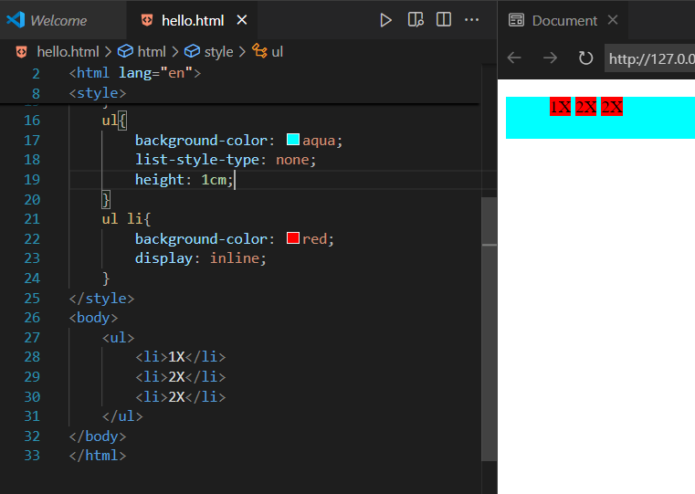

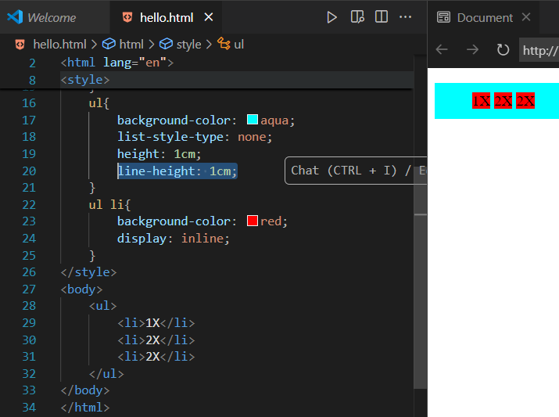

**Use inline block ->**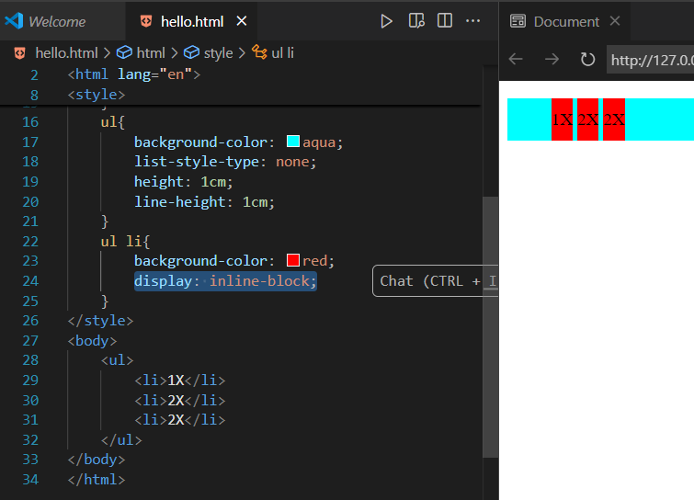

**Add padding left& Right**

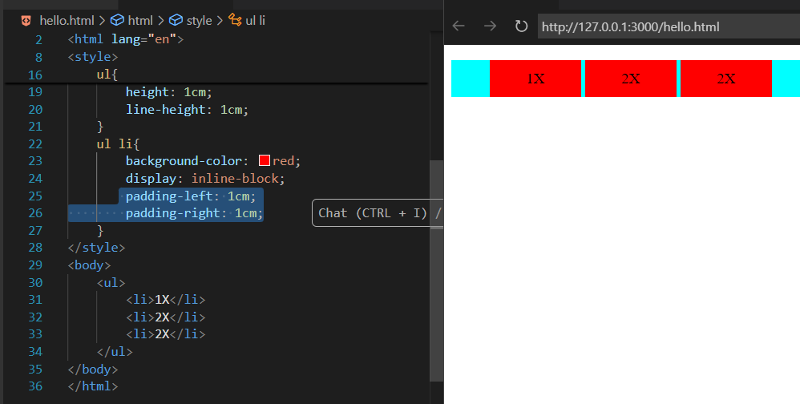

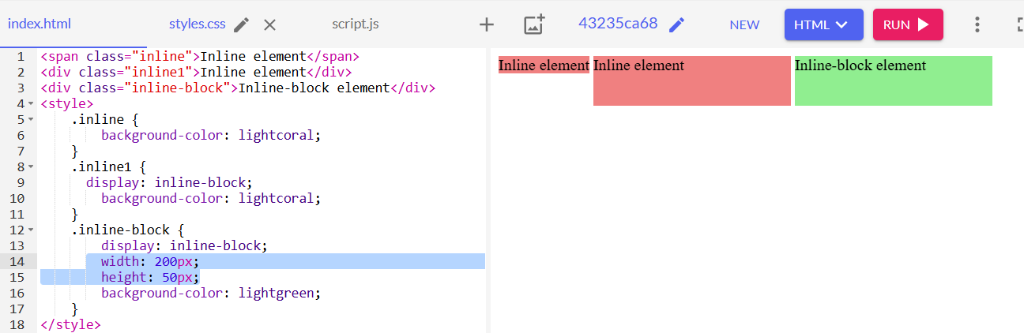

Display flex->

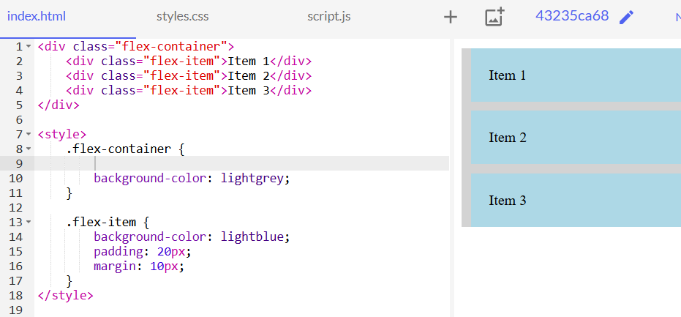

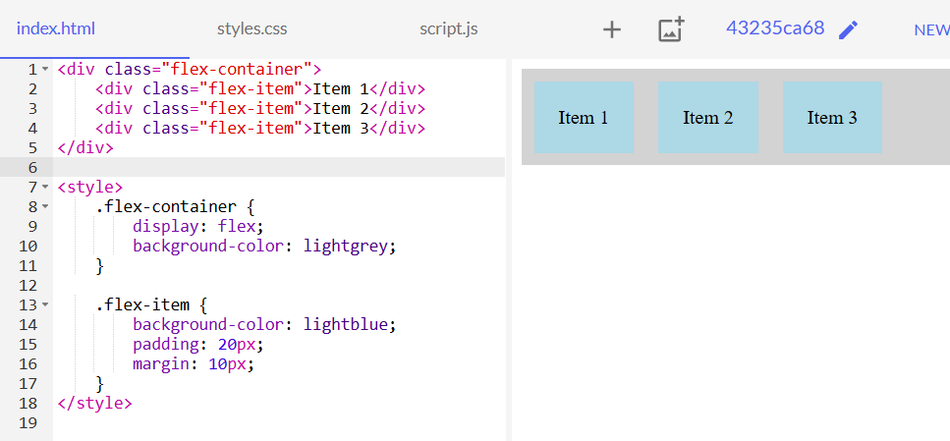

Inline display flex

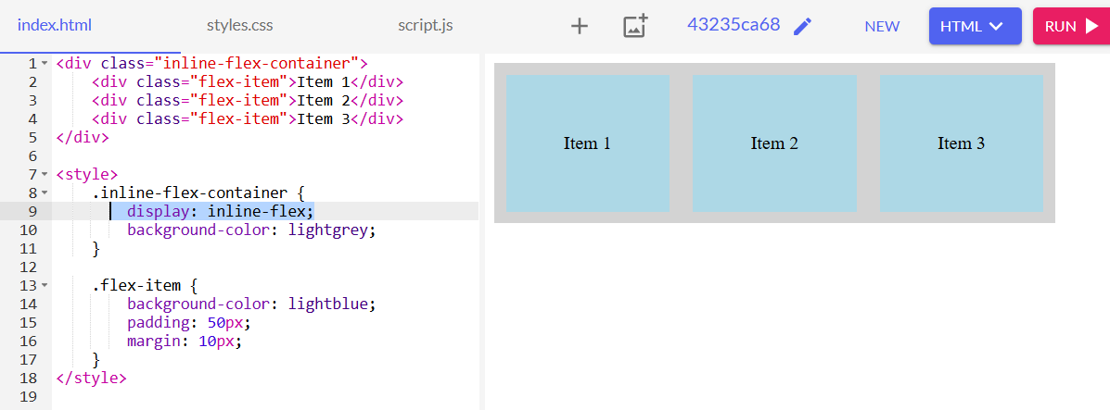

FLOAT 🡪

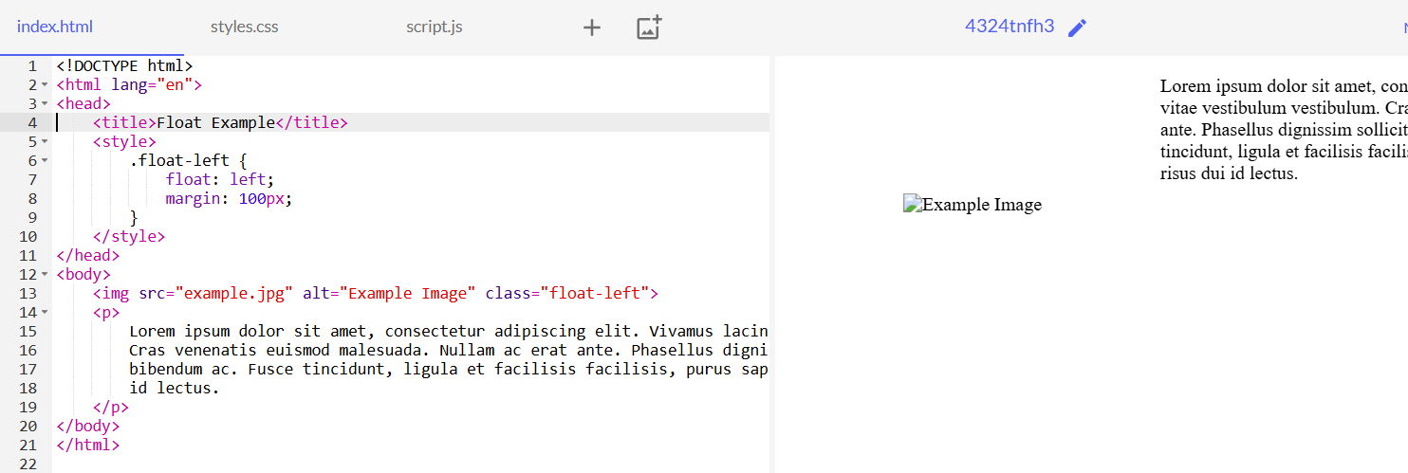

**Z-indexing**

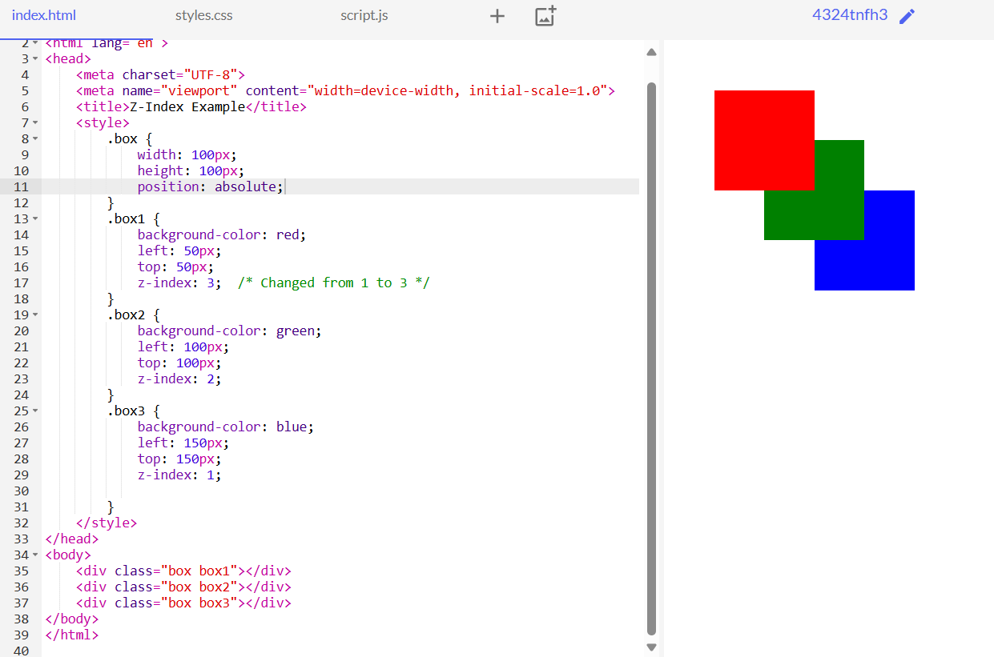

### Example: Basic Flexbox Layout

This example will show a container with three items, centered both horizontally and vertically using Flexbox.

### 1. Simplified Layouts

Flexbox simplifies the process of creating both simple and complex layouts. It provides a set of properties that allow you to align and distribute space among items in a container, making it easier to build layouts without using floats or positioning.

### 2. Responsive Design

Flexbox makes it easy to create responsive designs that adapt to different screen sizes and orientations. The flexible nature of Flexbox allows items to adjust and distribute space dynamically based on the container size.

### 3. Centralized Alignment

One of the most powerful features of Flexbox is its ability to align items both horizontally and vertically with ease. Properties like justify-content and align-items provide simple solutions for centering elements.

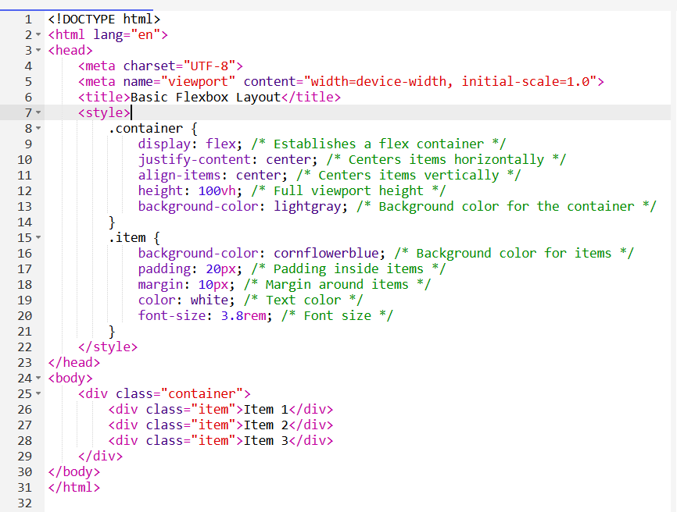

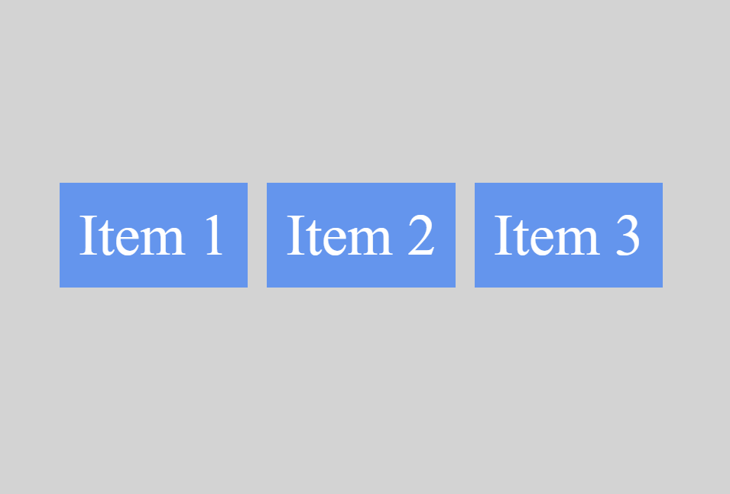

* --> Responsive Design
* Media Queries
* Viewport
* Responsive Units (vw, vh, %, etc.)

**Media Queries**

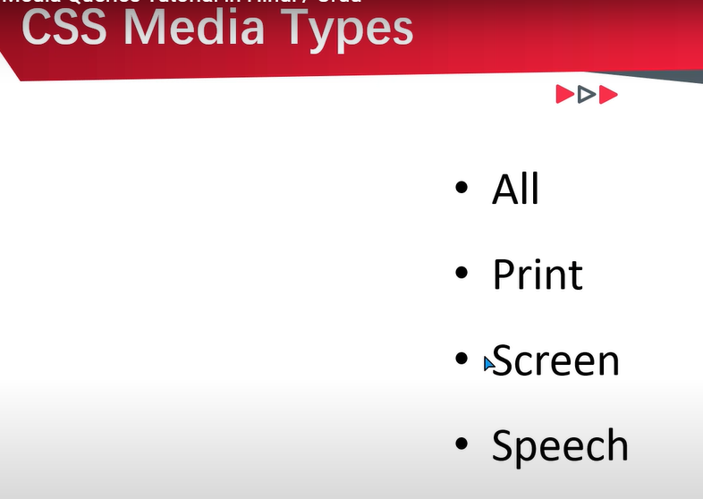

**View port -> width for Screen ,(tab,phone,laptop,PC)**

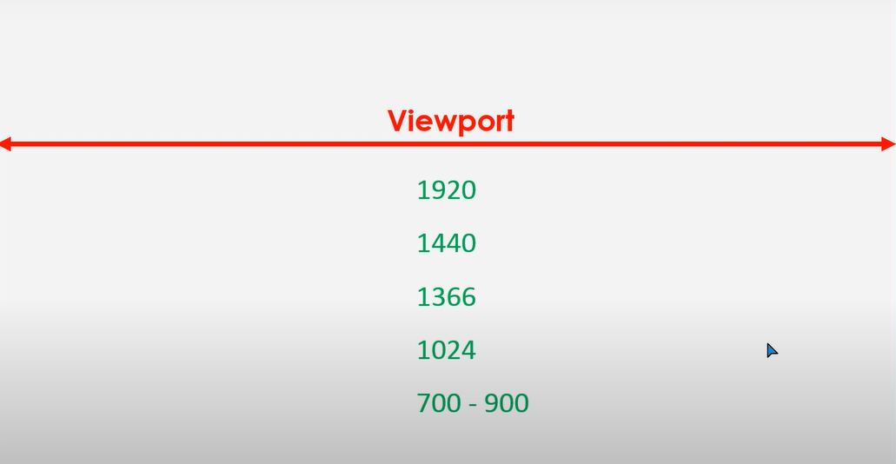

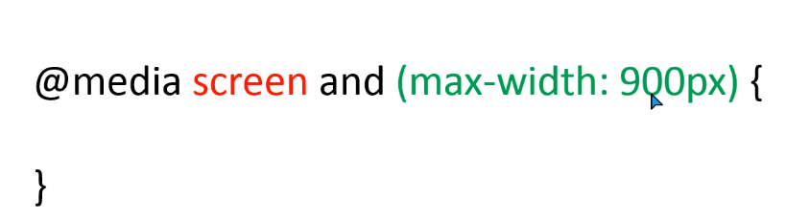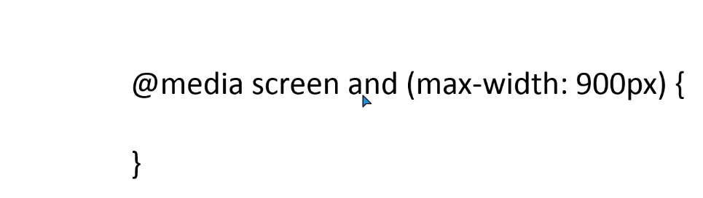

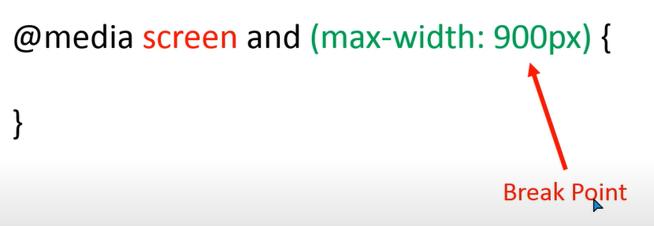

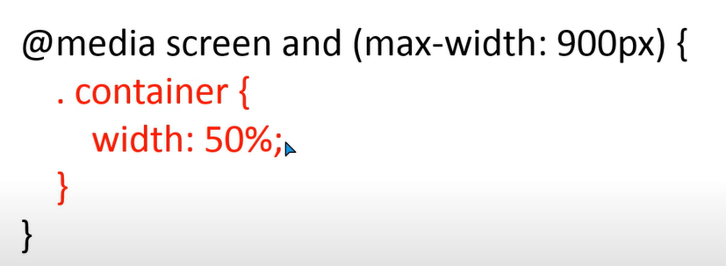

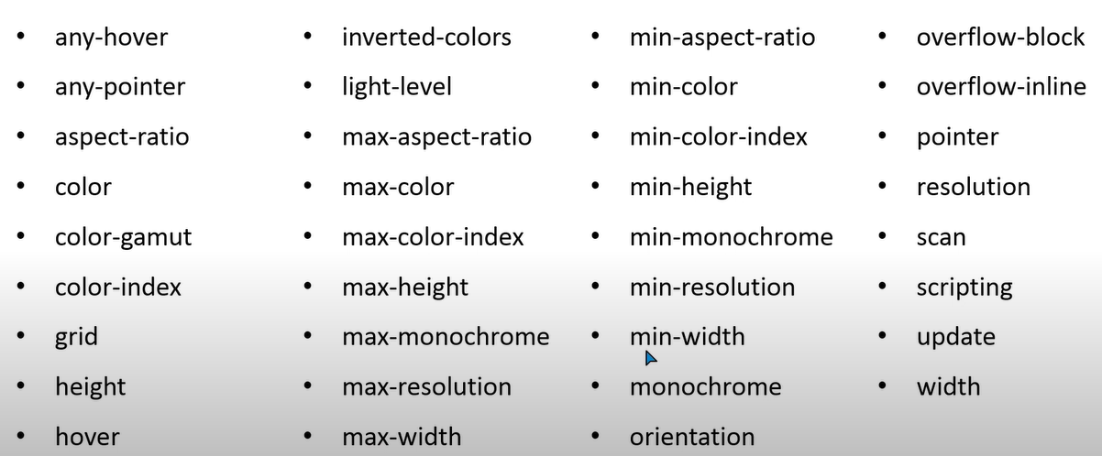

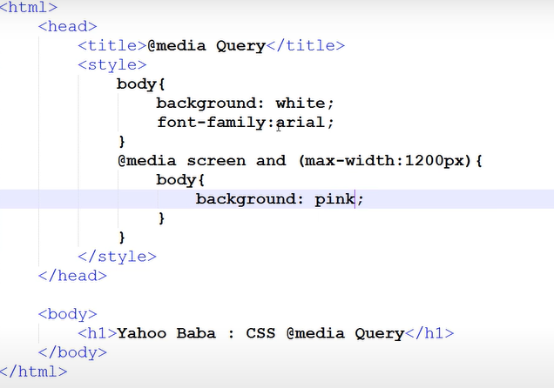

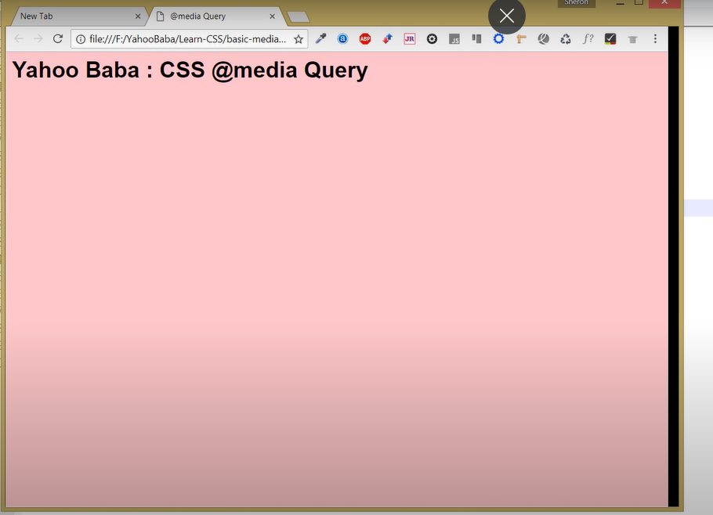

Multiple Condition apply for

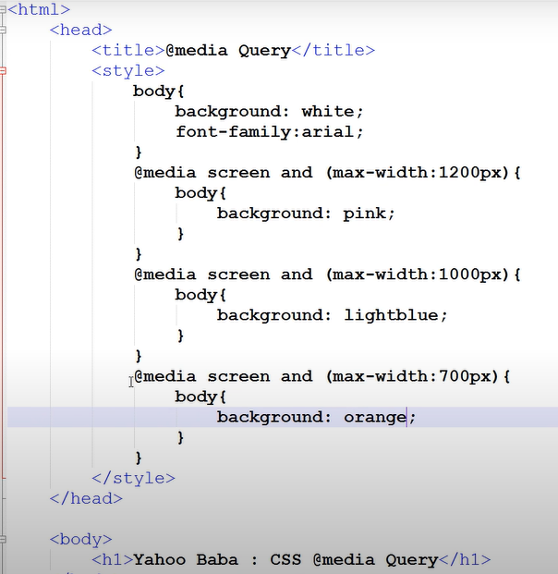

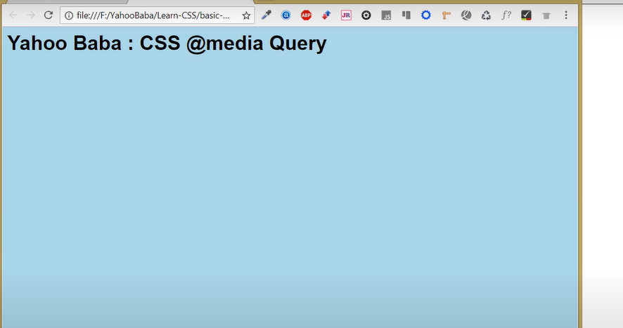



**ADD Font Size** 🡪

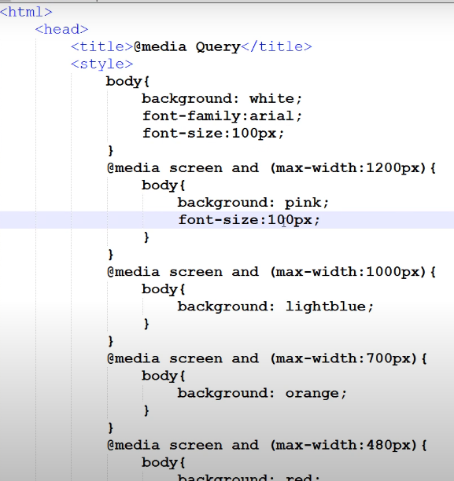

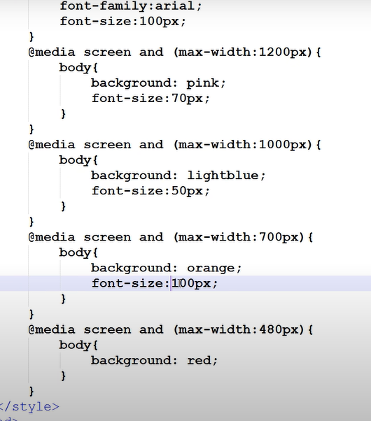

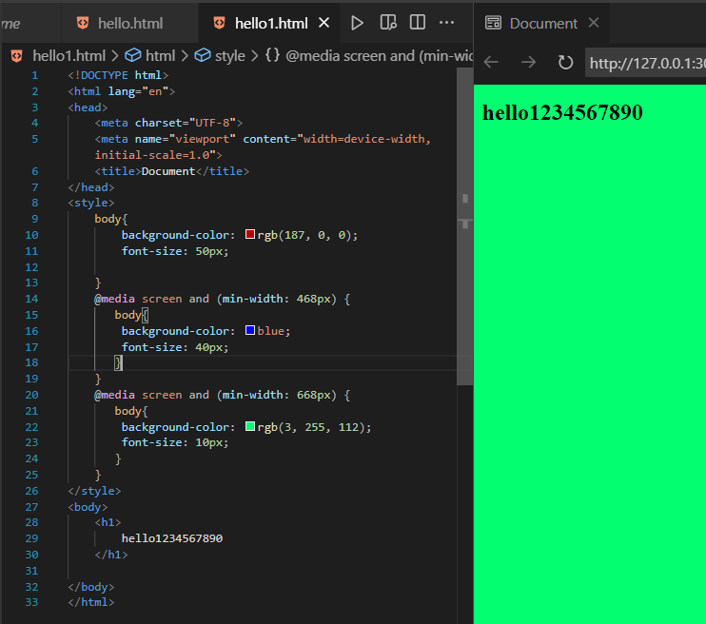

O/p ?

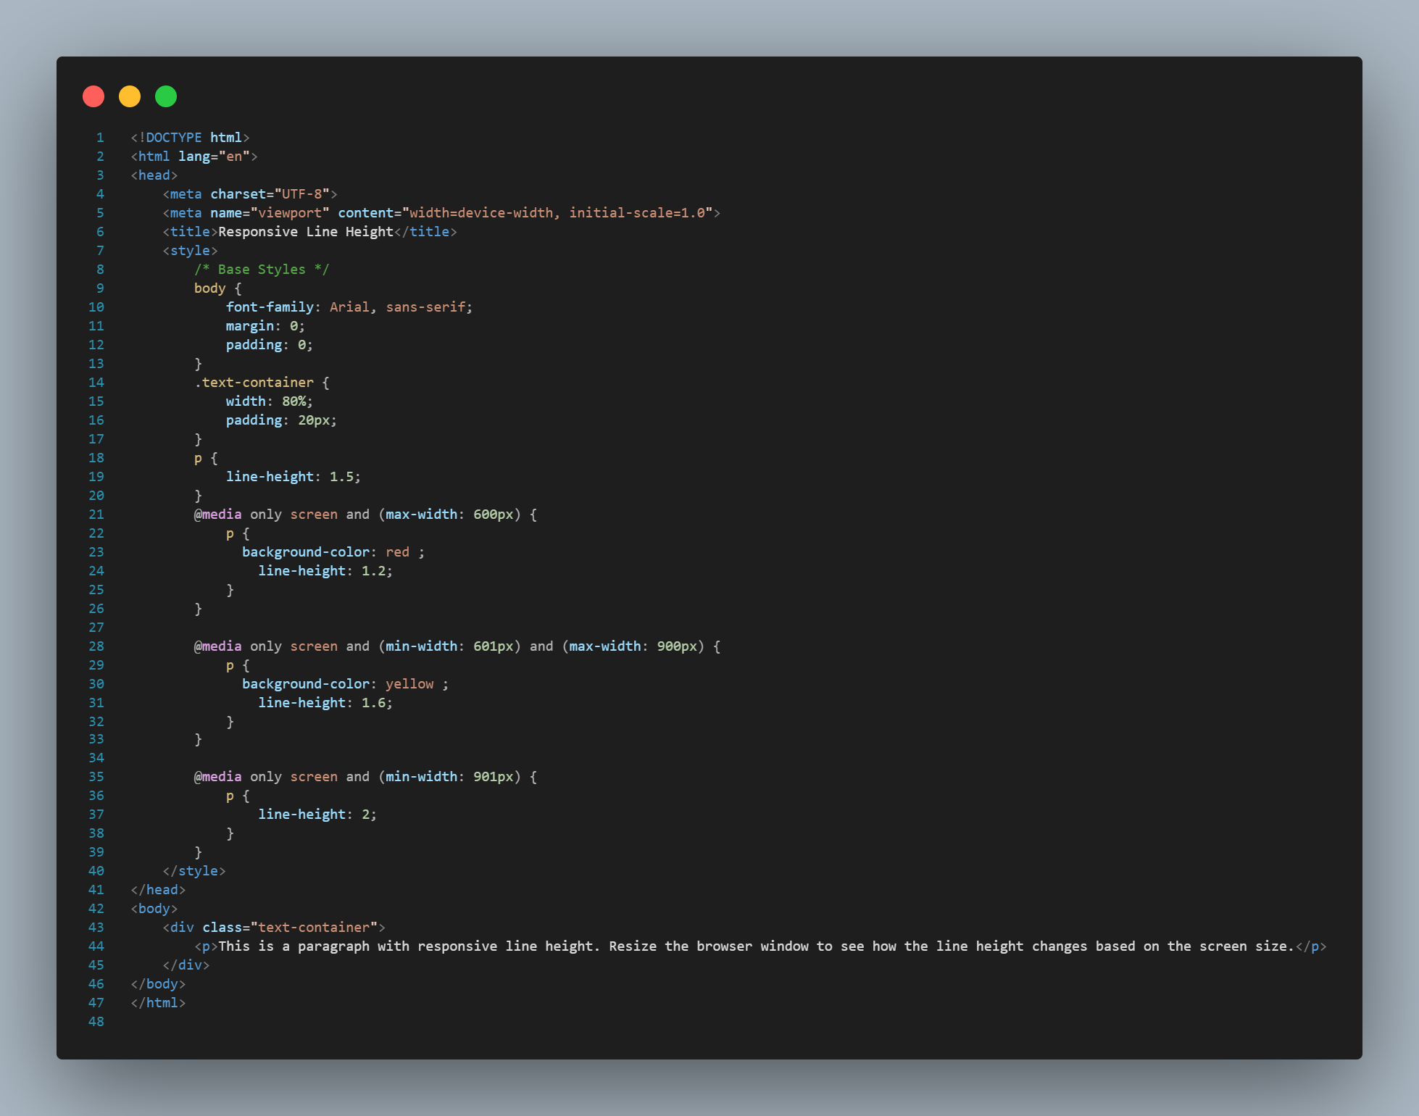

* **Viewport**

**Using Viewport Units:**

CSS viewport units jaise vw (**viewport width**), vh (**viewport height**), vmin aur vmax ko use karke tum layout ko responsive aur flexible bana sakte ho. Yeh units viewport ke size ke relative hote hain, jo responsive design mein kaam aate hain.

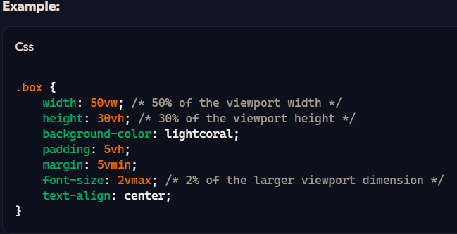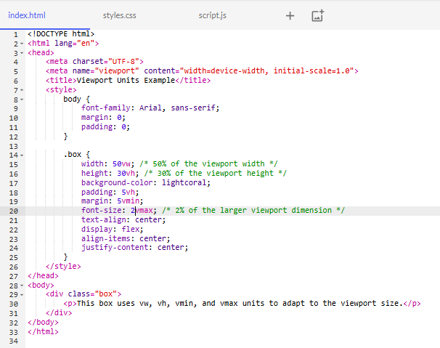

**CSS Transitions aur Animations ke differences ko table ke format mein diya gaya hai**:

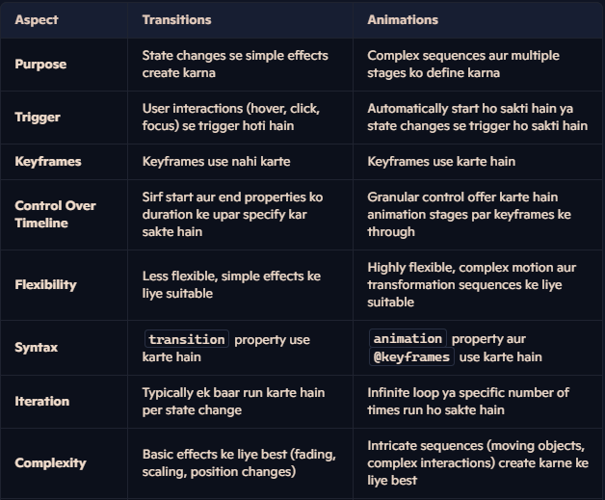

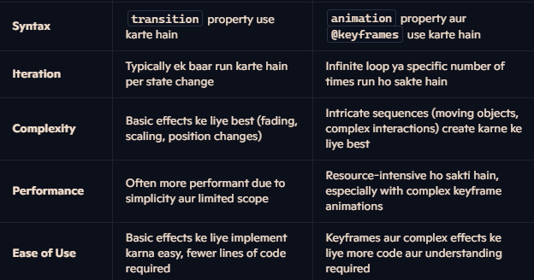

* calc()
* var()
* url()

🡪Calc ()

**Concept:** calc() function dynamically calculate karne ka feature deta hai. Iska matlab, hum different units ko combine karke ek value bana sakte hain jo container aur viewport ke size ke according adjust hoti hai.  
**calc()** function tumhe CSS properties ke values ko calculate karne ki facility deta hai. Iska use karke tum different units jaise pixels (px), percentages (%), viewport units (vw, vh), etc., ko combine karke ek dynamic value bana sakte ho.

Without calc()-> page

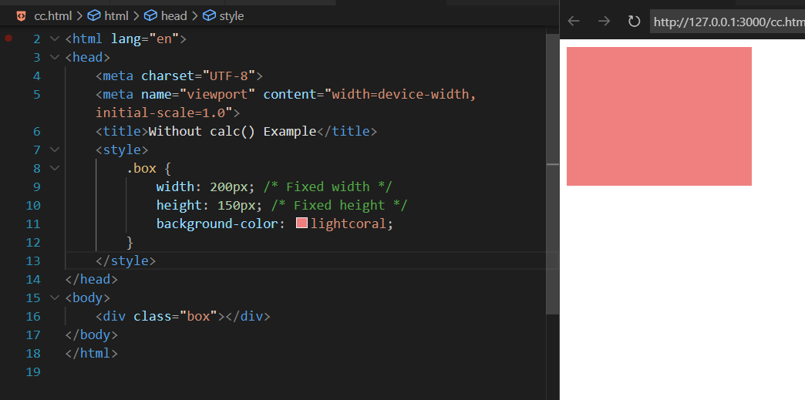

**With CALC()->**

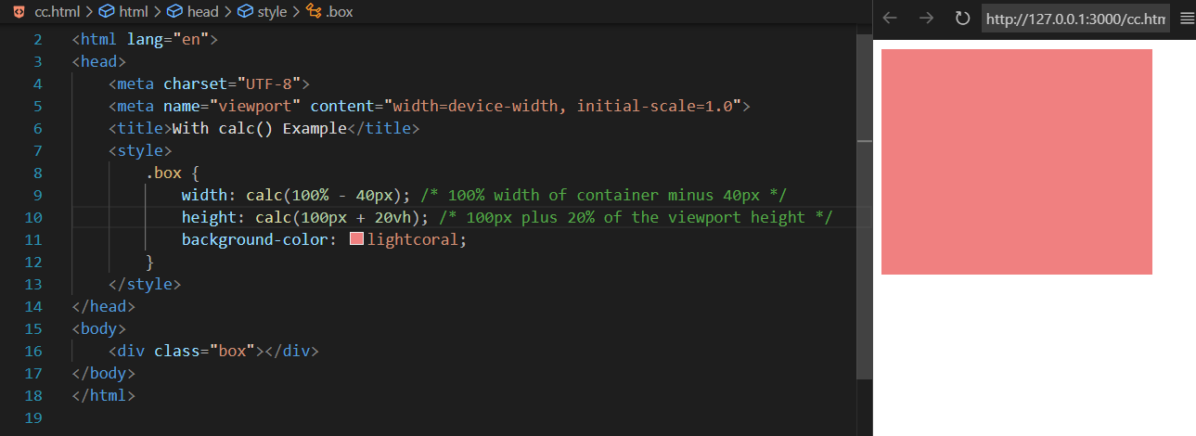

Var Example :

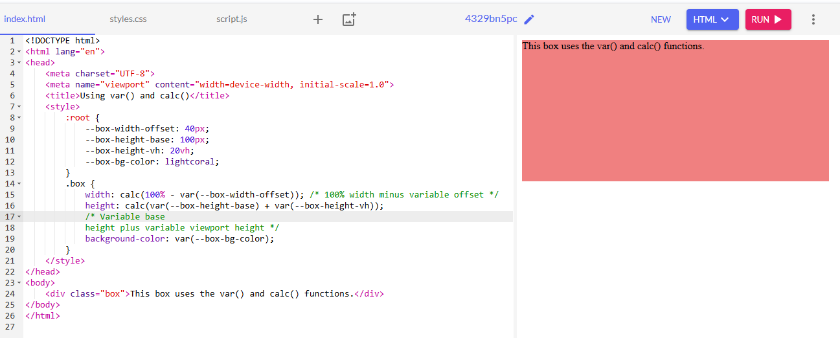

Another example

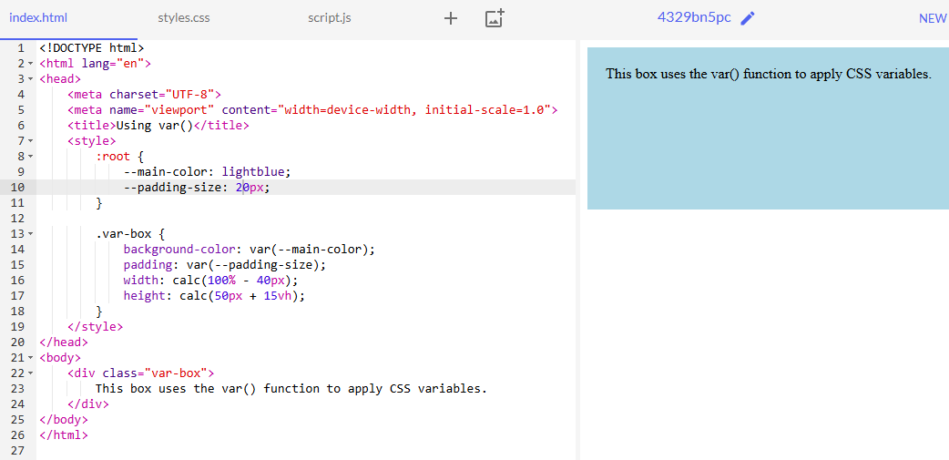

**Theory:** url() function is used to include external resources, such as images, fonts, or other files in your   
  
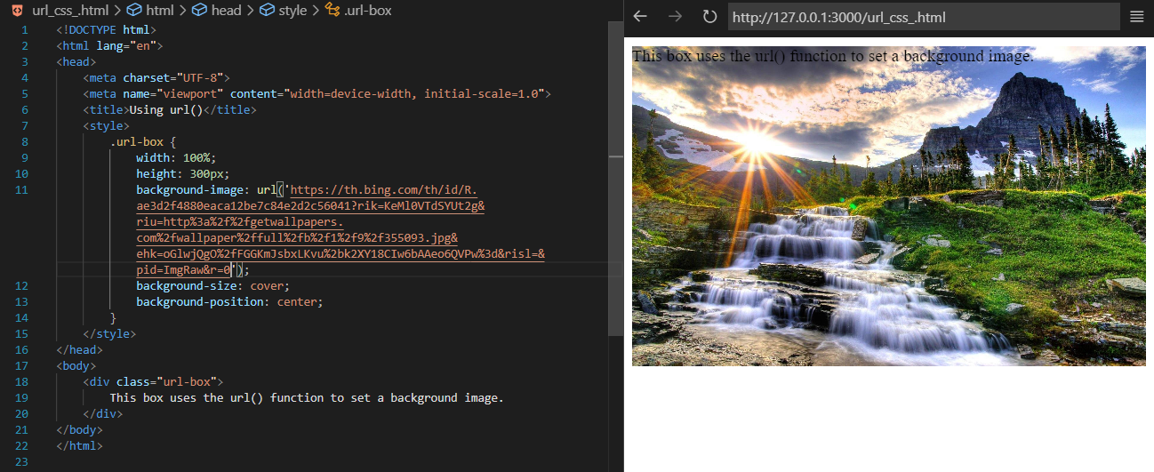CSS.  
The BOX is use Click:

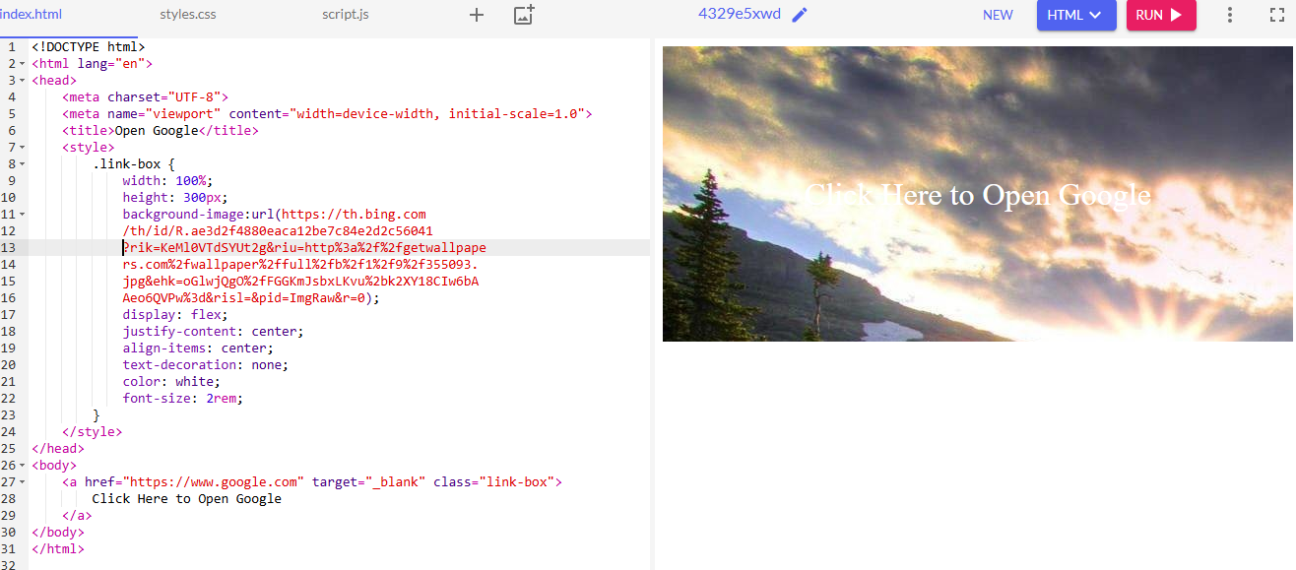

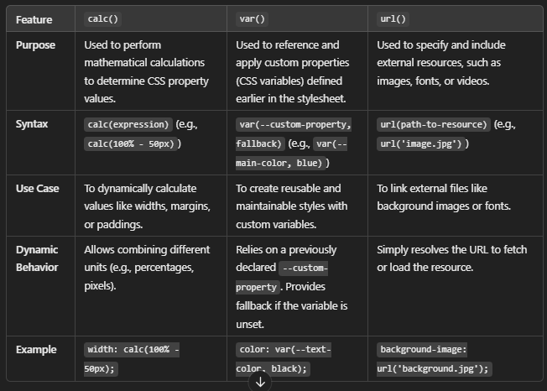

### • CSS Preprocessors (LESS, SASS) • CSS Frameworks (Bootstrap, Tailwind) • CSS-in-JS • Custom Properties (CSS Variables) CSS Preprocessors (LESS, SASS)

CSS preprocessors like LESS and SASS extend the capabilities of regular CSS by introducing features such as variables, nesting, and mixins. These preprocessors enable more efficient and maintainable styling through enhanced syntax and functionalities before compiling into standard CSS.

### CSS Frameworks (Bootstrap, Tailwind)

CSS frameworks like Bootstrap and Tailwind provide pre-designed, responsive components and utility classes, accelerating web development and ensuring consistency. Bootstrap offers a robust component library, while Tailwind focuses on utility-first styling for more customization.

### CSS-in-JS

CSS-in-JS refers to writing CSS directly within JavaScript files, enabling styles to be scoped to individual components. This approach, often used in React with libraries like styled-components and Emotion, promotes modular and reusable styling by integrating tightly with JavaScript logic.

### Custom Properties (CSS Variables)

CSS variables, also known as custom properties, allow developers to store values that can be reused throughout a document. Defined using --var-name and accessed with var(--var-name), they provide easier theme management and maintainability in CSS.

task 1 :

Create 🡪  
Create a webpage with a header, a paragraph, and a button. Style the header with a different color, the paragraph with a specific font size and margin, and the button with a background color and some padding.

